NAME: ______________________________________________________
INDEX NUMBER____________________
CANDIDATE’S SIGN ________________
DATE: _____________________________

232
PHYSICS
PAPER
(THEORY)
JUNE 2013

MID TERM EXAM 2013
FORM THREE PHYSICS

INSTRUCTIONS TO CANDIDATES
- Write your name and admission number in the spaces provided.
- This paper consists of two sections A and B. Answer all the questions in both sections the spaces provided.
- Mathematical tables and electronic calculators may be used.
- ALL working MUST be clearly shown where necessary.
- Take acceleration due to gravity as 10m/s²
FOR EXAMINERS USE ONLY.

SECTION | QUESTIONS | MAXIMUM SCORE | CANDIDATE’S SCORE
A | 1 – 12 | 25
B | 13 | 10
B | 14 | 7
B | 15 | 14
B | 16 | 13
 | 17 | 4
 | 18 | 7
TOTAL SCORE |  | 80
SECTION 1 (25 MARKS)
- The figure below shows a cylinder with water and ten lead pellets each of volume 1.8cm³.
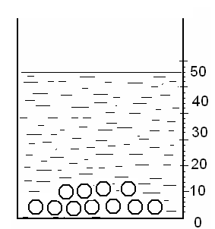

Indicate on the diagram the level of water if the pellets are removed. (2 mks)

- The diagram below shows two clear glass tubes containing water and mercury.

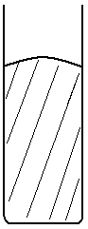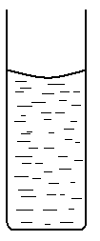

a b
Explain the shapes of the surface of each of the liquids inside the tube. (2 mks)

- 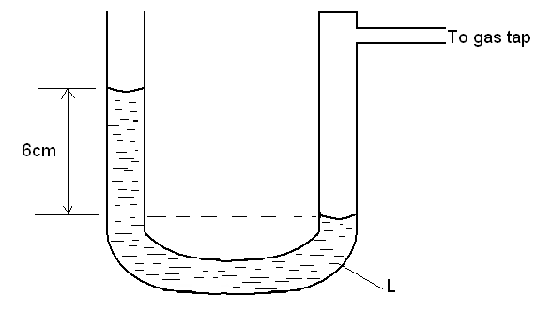The figure below shows a U-tube manometer containing a liquid L, one end in connected to a gas tap.

Given that the atmospheric pressure is 1.0 x 10⁵ pa, determine the pressure of the gas (density of liquid L is 900kg/m³. (3 mks)
(Take g = 10N/kg)

- The figure below shows a liquid in a long cylindrical tube closed at one end with a cork. The cork is tight fitting but movable. The system is in equilibrium.
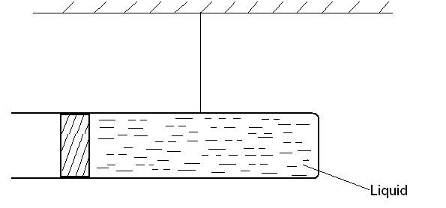

- State two observations that would be made when the tube is gently heated uniformly. (1 mk)

- Explain your observation above. (2 mks)
- Explain why in cold weather the metal blade of a knife feels colder that the wooden handle. (1mk)
- The figure below shows a uniform light rod balanced due to action of two forces shows. G is a magnet of weight 3N and H is a permanent magnet which is fixed.
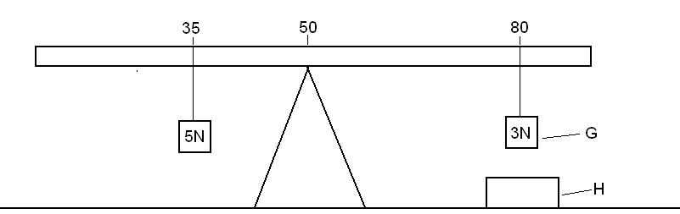

Determine the force between G and H. (3mks)

- In which state of equilibrium does the ball in the diagram below posses?(1mk)
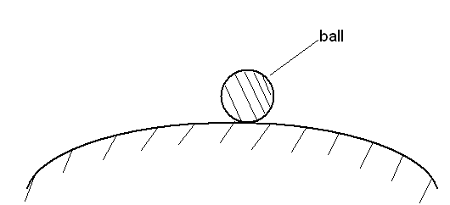

- (a) State the Bernoulli’s principle. (1 mk)

(b) A liquid flows along a horizontal pipe of cross-sectional area 20cm² with a speed of 5m/s. The speed increases to 8m/s where there is a constriction. Calculate the cross-sectional area of the constriction. (2 mks)

- State the law of conservation of linear momentum. (1 mk)

10.On the diagram below, draw two rays from the point A to illustrate how the eye sees its image. Also draw the image of the whole letter L. (3 mks)

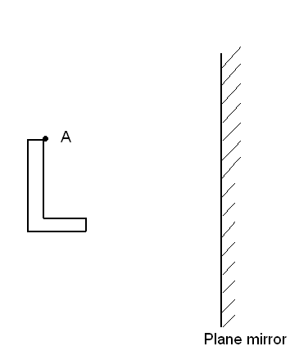

11.Explain why a rubber balloon, if rubbed will often stick to the wall where it has been rubbed. (2 mks)

12.Smoke was trapped in a smoke cell and viewed through a lens. State the change in movement of the smoke particles when the temperature of the room was lowered. (1 mk)

SECTION B (55 MARKS)

13The diagram below (not drawn to scale) shows a velocity – time graph. Use it to answer the questions that follow.
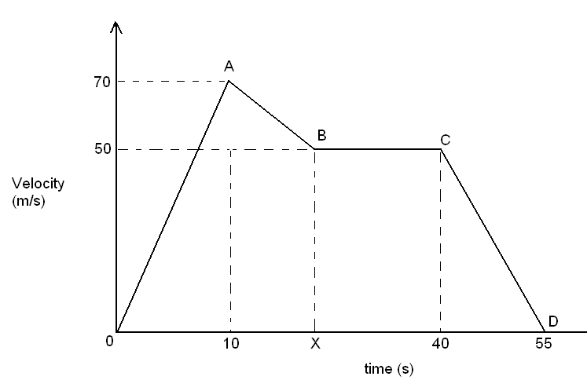

- If the acceleration between points A and B is -1.25m/s², determine the value of x. (3 mks)

- Describe the motion of the body. (4 mks)

- Calculate the distance covered by the body during the whole journey. (3 mks)

14.(a) State the Hooke’s law. (1 mk)

- The following readings were obtained when different masses were hung on a certain spring.

Mass (kg) | 0 | 0.02 | 0.04 | 0.06 | 0.08
Pointer reading (mm) | 110 | 125 | 141 | 156 | 172

- Plot a graph of force F (N) against extension e (mm) (5 mks)

- From the graph, determine he spring constant. (1 mk)

15.(a) State three conditions necessary for two progressive waves moving in opposite directions to form a stationary wave. (3 mks)

(b) State two differences between stationary and progressive wave. (2 mks)

(c) The figure below shows a wave. Use it to answer the questions that follow.
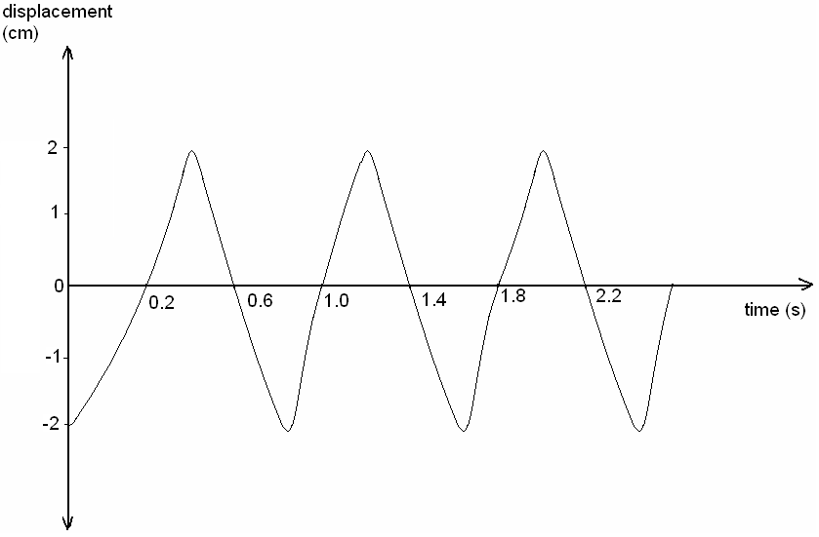

- Identify the type of wave giving a reason for your answer. (2 mks)

- State the period of the wave. (1mk)

- If the wave has a wavelength of 2 x 10⁻²m, determine the speed of the wave.
(4 mks)

- On the same axis, sketch a wave with half the amplitude and double the period. ( (2 mks)

16.(a) State the snell’s law. (1 mk)

- A student carried out and experiment on refraction of light incident on a glass block. She obtained the following.

i | r | Sin i | Sin r
20º | 12.7 º
30º | 18.9 º
40º | 25.0 º
50º | 30.0 º
60º | 34.0 º
70º | 37.0 º
(i). Complete the table for the values of sin i and sin r. (1 mk)

(ii). Draw the graph of sin i (y – axis) against sin r. (5 mks)

(iii). Determine the slope of the graph. What does it represent? (4 mks)

(iv). Use the results in b (iii) to calculate the velocity of light in glass, given that velocity of light in vacuum is 3.0 x 10⁸ m/s. (3 mks)

17.(a) The diagram below shows a simple electric motor.
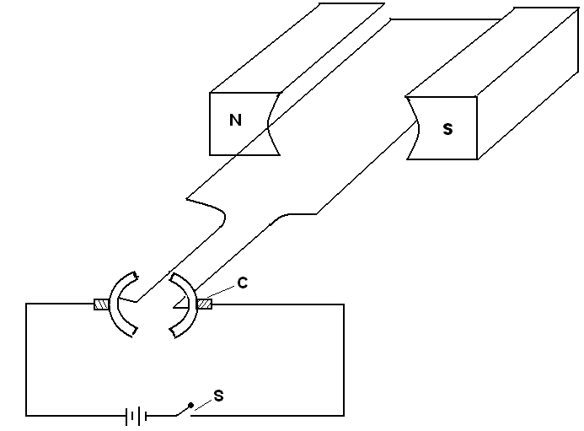

- Name the part labeled c. (1 mk)

- State two factors that will affect the speed of rotation of the motor. (2 mks)

- By use of an arrow, show the direction in which the coil will rotate when the switch s, is closed. (1 mk)

18.A Wave travels from deep to shallow as shown below. The velocity in deep water is 12 cm/s and the wave length of the wave is 3 cm.

Deep Shallow

a) Continue the wave path in shallow water (2 marks)

b) State the changes which occur to the wave when it crosses from deep to shallow water (2 marks)

c) Calculate the wavelength of the wave in shallow water given that its velocity is 8 cm/s. (3 marks)

