TERM 2 MID TERM TESTS 2013
GEOGRAPHY FORM 4
Section A

Answer all the questions in this section
- Qn1 (a) Name two elements of weather that can be recorded at a school weather station.(2mks
(b) Give three reasons why the recording of data at a school weather station may be inaccurate. (3mks)
- Qn2 (a) State two factors which influence the occurrence of surface run- off.(2mks)
(b) The diagram below shows a waterfall. Name the feature marked X, Y and Z.(3mks
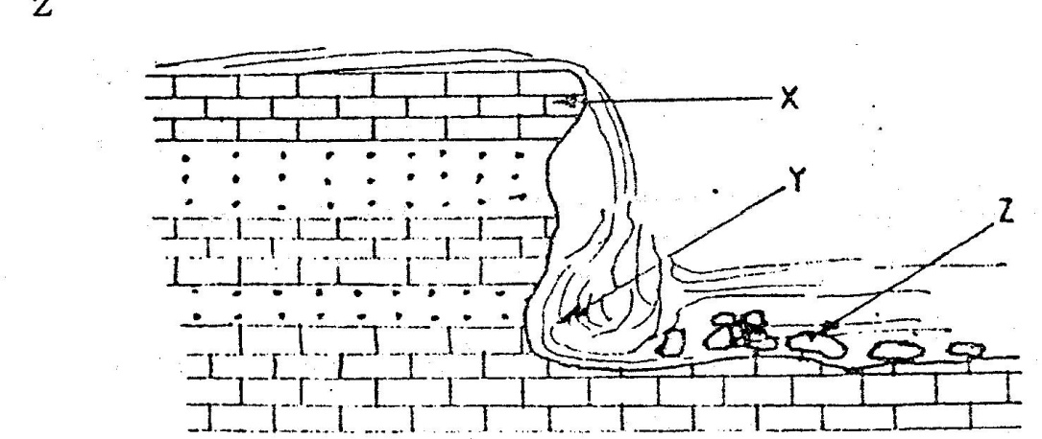
- Qn3 (a) State two causes of submergence of coasts. (2mks)
(b) Name three features which are formed by waves erosion. (3mks)
- Qn4 (a) What is soil? (2mks)
(b) Draw a diagram showing soil catena and name three major parts(3mks
Qn5. The diagram below shows a valley glacier. use it to answer the questions that follow.

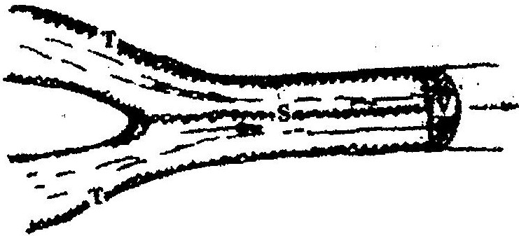

- Name the type of moraines marked S, T and V (3mks)

- (b)Give two mountains out side Kenya that are ice capped. (2mks

SECTION B
Answer questions 6 and any other two questions from this section
Qn6(a) Study the map of Kijabe 1: 50,000 provided and answer the following
questions:
(i) What is the appropriate height of the top of Kijabe hill?
(ii) Measure the length of Nairobi – Naivasha railway line from landhies (grid
reference 257978) to the level crossing near Kijabe station ( grid reference 308984). Give your answer in kilometers.
(iii) What relief feature on the map may have created problems in the construction of the railway line?
(b) Describe the drainage of the area covered by the map
(c) Explain how relief has influenced the distribution of settlement in the area covered by the map.
(d) Citing evidence from the map, state four economic activities carried out in the area covered by the map.
(e) Suppose you were a student in the school at Kinari ( Kinale) and you plan to carry out a field study of Wakagwe forest,
(i) Design a working programme (schedule) you would use during the day of the study
(ii) Give three reasons why it would be necessary to sample part of the forest for the study
(iii) State two ways in which your findings would be useful to the local community

Qn7 (a) Differentiate between plutonic rocks and volcanic rocks
(b) Describe how lava plateau is formed
(c) (i) Name three volcanic features found in the rift valley of Kenya
(ii) Explain four negative effects of vulcanicity in Kenya
- You intend to carry out a field study of a volcanic landscape
- State four reasons why it is necessary to conduct a reconnaissance of the area of study.
- During your field work, you intend to study volcanic rocks, state why you would need the following items

- Qn8(a) State three characteristics of the inter-tropical convergence zone
(b) With the aid of a labeled diagram, describe how relief rainfall is formed
(c) State five characteristics of the hot desert climate
(d) You are required to carry out a field study to determine the relationship between
climate and vegetation in your district
- Give three reasons why you would need the map of the district
- Name two sampling techniques you are likely to use during the field study
- Give two reasons why sampling would be appropriate for this study
- State four methods you would use to record data during the filed study

- Qn9(a) (i) Describe how lake Victoria was formed
(ii) Explain how Lake Victoria has modified the climate of the surrounding
(b) Explain why some lakes in the rift valley have fresh water
(c) State five economic uses of lakes
(d) Explain how each of the following have affected lakes in Kenya
(i) Deforestation
(ii) Industrialization
(iii) Water weeds
- (8mks)
Qn10. a) (i) Two process through which wind erodes the surface
(ii) Three ways through which wind transports its load
b) (i) How an oasis is forced
(ii) How zeugens are formed
You are supposed to carry out a field study of a semi-arid area in Kenya.
c) (i) Two ways of preparing for the Field study
(ii) Information that would be collected through observation of the arid area
(iii) Measures to be recommended for controlling desertification.

