NAME…………………………………….ADM NO……………….CLASS…………

TERM 2MID TERM TESTS 2013
GEOGRAPHY FORM 3

Answer all questions in the spaces provided.

1(a) Give two theories which explain the origin of the earth and the solar system. (4mks

………………………………………………………………………………………………………………………………………………………………………………………………………………………………………………………………………………………………………………………………………………………………………………………………

(b) Write three characteristics of the core (6mks

………………………………………………………………………………………………………………………………………………………………………………………………
………………………………………………………………………………………………………………………………………………………………………………………………
………………………………………………………………………………………………………………………………………………………………………………………………
2(a) Writes four importance of learning geography in a schools (8mks

………………………………………………………………………………………………………………………………………………………………………………………………
………………………………………………………………………………………………………………………………………………………………………………………………
………………………………………………………………………………………………………………………………………………………………………………………………………………………………………………………………………………………………………………………………………………………………………………………………
………………………………………………………………………………………………………………………………………………………………………………………………
………………………………………………………………………………………………
(b) Give two planets in our solar system which do not have natural satellites (4mks

………………………………………………………………………………………………
………………………………………………………………………………………………
3(a) Distinguish between weather and climate (4mks

………………………………………………………………………………………………………………………………………………………………………………………………
………………………………………………………………………………………………………………………………………………………………………………………………
(b) Write three different types of precipitation (6mks

………………………………………………………………………………………………………………………………………………………………………………………………
………………………………………………………………………………………………………………………………………………………………………………………………
………………………………………………………………………………………………………………………………………………………………………………………………
4 (a) Explain three problems facing gold mining in South Africa. (6mks

………………………………………………………………………………………………………………………………………………………………………………………………
………………………………………………………………………………………………………………………………………………………………………………………………
………………………………………………………………………………………………
(b) Describe four –ways in which Kenya is likely to benefit by drilling the recently discovered petroleum. (8mks

………………………………………………………………………………………………………………………………………………………………………………………………
………………………………………………………………………………………………………………………………………………………………………………………………
………………………………………………………………………………………………………………………………………………………………………………………………………………………………………………………………………………………………
5(a) Distinguish between faulting and folding. (2mks

………………………………………………………………………………………………………………………………………………………………………………………………
………………………………………………………………………………………………………………………………………………………………………………………………

(b) The block diagram below represent part of earth’s crust which has been
subjected to tensional forces.

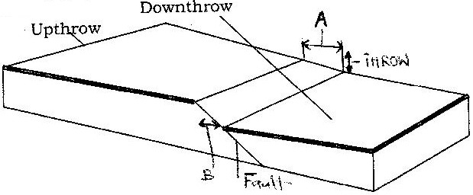

Name

(i) the slope marked A (2mk)

………………………………………………………………………………………………………………………………………………………………………………………………
(ii)Explain three ways in which faulting can influence drainage systems. (6mk)

………………………………………………………………………………………………………………………………………………………………………………………………
………………………………………………………………………………………………………………………………………………………………………………………………
………………………………………………………………………………………………………………………………………………………………………………………………
………………………………………………………………………………………………………………………………………………………………………………………………
………………………………………………………………………………………………
(c)With aid of well labelled diagrams, describe the formation of Fold Mountains. (10mks

(d) Explain four positive effects of folding. (8mks

………………………………………………………………………………………………………………………………………………………………………………………………
………………………………………………………………………………………………………………………………………………………………………………………………
………………………………………………………………………………………………………………………………………………………………………………………………
………………………………………………………………………………………………
6. Study the map of Homa Bay (1:50,000) sheet 129/2 provided and answer the following questions.

(a) A pipeline is to be laid from Lake Victoria along the line marked X-Y.

(i) What is the length of the piping to be used? (Give your answer to the nearest 100 metres). (2mks)

iii) Calculate the bearing of point Y from point X. (2mks

.
(iii) Calculate the area of the part of Lake Victoria shown on the map excluding the marshy sections. (Give your answer in square kilometers). (3mks

(b) The rectangle below represents the area in the map extract bounded by Eastings 54 and 60 and Northings 35 and 40. Identify and name the features marked J, K, L and M. (4mks.

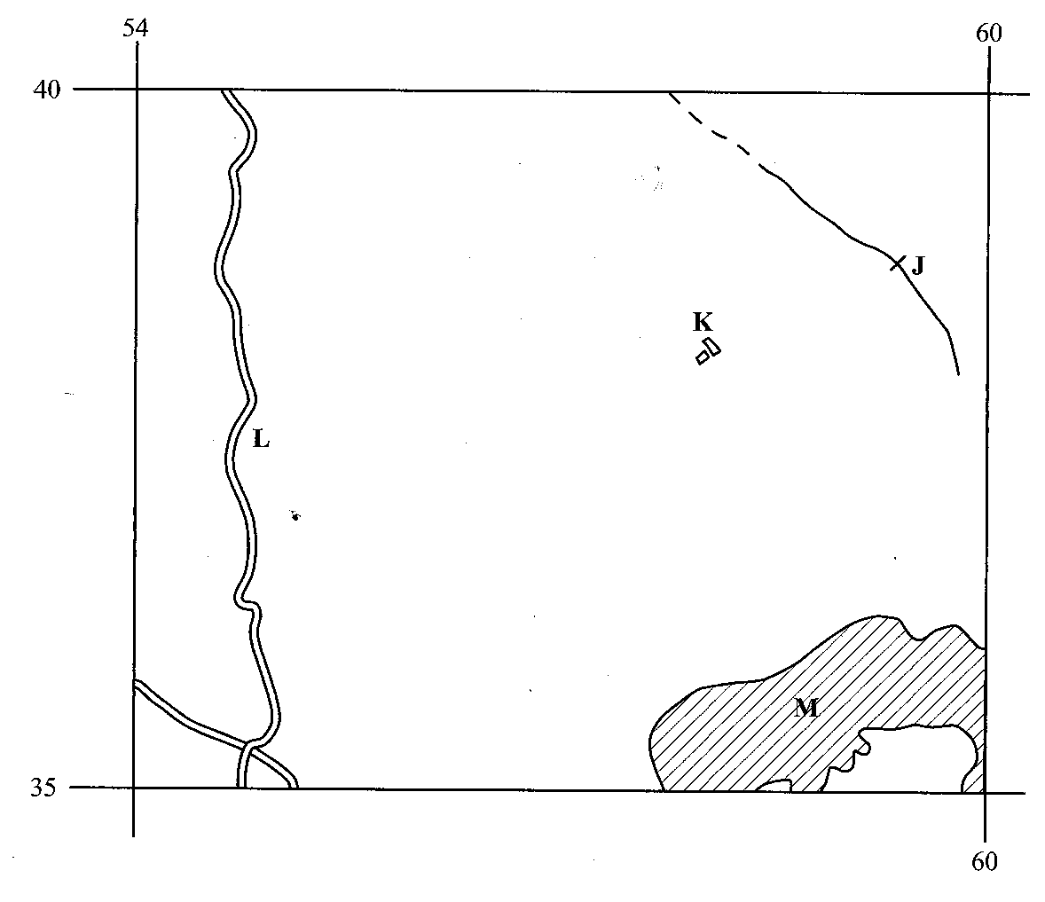
J ________________________________________________________
K _______________________________________________________
L _________________________________________________________
M __________________________________________________________
(c) (i) Explain three factors which have influenced the distribution of settlements in the area covered by the map. (6mks

………………………………………………………………………………………………………………………………………………………………………………………………
………………………………………………………………………………………………………………………………………………………………………………………………
………………………………………………………………………………………………………………………………………………………………………………………………(ii) Citing evidence from the map, give two agricultural activities carried out in the area covered by the map. (4 marks)

………………………………………………………………………………………………………………………………………………………………………………………………
………………………………………………………………………………………………………………………………………………………………………………………………
(d) Describe the drainage of the area covered by the map. (5mks)

………………………………………………………………………………………………………………………………………………………………………………………………
………………………………………………………………………………………………………………………………………………………………………………………………
………………………………………………………………………………………………………………………………………………………………………………………………
………………………………………………………………………………………………………………………………………………………………………………………………
………………………………………………………………………………………………………………………………………………………………………………………………
………………………………………………………………………………………………………………………………………………………………………………………………
……………………………………………………………………………………………………………………………………………………………………………………………

