MUTITO FORM FOUR JOINT EVALUATION TEST

Kenya Certificate of Secondary Education

451/1
COMPUTER STUDIES
PAPER 1
(THEORY)

MARKING SCHEME

- To avoid loss of data.
To avoid damage of programs.
To avoid damage of computer parts. (Any 2 correct @ 1 mark total of 2mrks)

- a) Not portable
- Consume a lot of heat.
- Cheap
- Curved screen
(Any 4 correct @ ½ mark total of 2mrks)
b) Liquid Crystal Display (LCD)
Thin film Transistor (TFT)
Gas Plasma
(Any 2 correct @ 1 mrk = 2 mrks )
- Massive capacity.
Stores data permanently
Secure
High quality picture & sound.
(Any 4 correct @ ½ mrks = 2 mrks)
- May not meet special needs
Not efficient
Changes leads to extra cost.
Not all packages are compatible.
(Any 4 correct @ ½ marks = 2 marks)
- Command line: - Users interact by typing a command at the prompt.
Menu driven interface: - Allows users to select commands from a list
Graphical user interface: - Users click on commands represented as a picture.
(Name and explain @ 1mrk total = 3mrks)
- i) Insert mode – Text inserted between words or characters. Pushes existing text away without
replacing it.
Type over mode:- Text typed automatically replaces the existing text.
(correct @ 1mrk = 2 marks)
ii) Alignment:- it’s how text is lined on the page relative to left, right or center of the page.
Indentation:- Moving the text away from the margin.
(Correct @ 1mrk = 2 marks)
- a) i) SUM IF :- Adds values in the cells specified by a given criteria.
ii) COUNT :- returns the number of cells within a specified range that meet the given condition.
2 marks
b) Feature involving changing the value of one argument in a formula to see the change it would make on the calculation. (correct = 2marks)
- Bound: - The source of data is a field is a table/query.
Unbound:- Control is connected to any data source (correct @ 1 = 2 marks)
- Using hand tool.
Using scroll ball.
Using zoom tool. (Any 3 correct @ 1mrk Total = 3mrks)

- Crimes are very complex
Difficult to find a clear trail of evidence.
No witness to compute crimes.
Law enforcement is not efficient. (Any 4 correct @ ½ mrk = 2 marks)

- Suitability of communicating data
Responses time.
Initial cost of installation.
Control over resources. Any 4 correct @ ½ marks = 2 marks)

- a) Costly due to redundant cables.
Difficulty to install and maintain. Any correct 2 @ ½ mark = 1 mark

b) Make sharing of resources possible.
Transmitting data
Responds to request Any 2 correct @ ½ mark = 1 mark

- a) Ability of a computer to think and reason like human being. Correct total 1 mark

b) Expert systems.
Computer vision.
Neural network
Robotics Any 4 correct @ ½ marks = 2 marks

- a) Smaller in size
High speed
Improved use interface
More intelligent Any 4 correct @ ½ mark = 2marks

b) Increased efficiency
Improve customer service
Reduce cost Any 2 correct @ ½ mark = 1 marks

- System analyst
We designer
Programming Any 3 correct @ 1 mark total 3marks

- Start Start/Stop @ ½ mrk = 1
Print “Enter A) Input = 1mrk
Input A decision if … Then = 1mrk
Initialize A, ADD Process ADD = ADD +A
A = 11 A = (A + ADD = 2mrks
ADD = 0
If A < 100 THEN
End If End IF = 1mrk
A = (A + ADD)2
STOP Out put = 1mrk

- Add = 11, A = 11, A = 16 ½ , A = 22, A = 35 ½
ADD = 22, ADD = 27 ½ , ADD 49 ½
@ Correct 1mrk = 8mrks

19
(a)
i) In sequential files organization files are accessed in order sorted using a key field whereas in serial tile organization files are accessed one after another but they are stored at random(not sorted) (2mks)

ii) In random file organization records in a file are stored randomly but accessed directly whereas Index sequential is similar to sequential tile organization only that index is used to enable the computer to locate individual record on
the storage media (2mks)
(b)
i) In batch processing ,data is accumulated as a group (batch) over a specified period of time, eg. i)aily, weekly, monthly etc. (2mks)
ii) in a reel time data processing computer processes the incoming data as soon as it occurs up —dates the transaction file and give an immediate response that world affect the event as they happen. (2mks)
(c) Undo — This is a command used to cancel the operation that has just been processed (2mks) Redo — This is used to reinstate the command that was cancelled (link)
(d)
> Expert system
> Diagnosis
> Keep patients record
> Used in hospital for stock control
> Use to manage finances
(3mks for any three correct answers)
(e)
> DiploinainiCT
Certificate in ICT
Diploma in computer science
> Certificate in computer science
(2mks for any two correct answers)
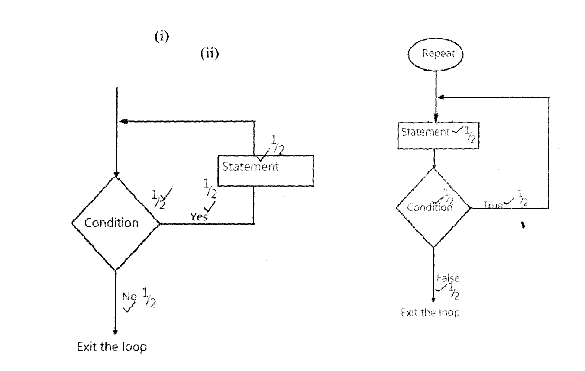
- a) i) Involves sub- division of a process into several sub process then each can be processed at
different site co- currently hence speeding up entire process.
Correct 2 marks
- Involves transmission of data signals between two communication devices located at different
geographical locations.
Correct total 2 marks
- Portable
Convenient Any 4 correct @ ½ mark = 2marks

- Logical – deals with the way data passes from one devices the next on the network.
Physical – Physical arrangement of devices on the network. Correct @ 1 mark = 2 marks

- Parallel – Both the old and the new systems run at the same time until gains confidence.
Direct - Complete replacement of the old systems with the new system
Correct @ 1 mark = 2 marks
- File conversion
Staff training.
Project management
Changeover strategies Any 3 correct @ 1 mark = 3 marks

- a) Overflow – occurs when results from calculations is too large to fit in the allocated memory.
Truncation:- Occurs in case a real number has a long functional part which cannot fit allocated
memory space. Correct and any 2 @ 1 marks 2 marks)

- Back up.
Enforce security measures
Use direct data capture devices
Use error detection & conversion software Any 4 correct @ ½ marks total 2mrks

- Data duplication
Programming problems.
Security threats Any 3 correct @x 1 mark = 3 marks

- Logical file:- This what data items it contains and what processing operations may be preformed.
Physical file:- Is how data items are found in a file and arranged on a storage media.
Correct = 1mrks
- Compilers are fast:- entire source code once.
Interpreters:- translates a program each time it runs.
Correct 2 @ 1 mark = 2 mark
- Dry running
Translator system checking
Use of debugging utilities
Use of test data. Any 4 correct @ ½ marks = 2 marks

- Easy to read
Easy to run and code
Easy to modify
Easy to test
Flexible Any 4 correct @ ½ mark = 2 marks

- a) i) There is use of protocols – rules govern how devices communicate on a network.
Correct 2 marks
ii) Modem
Hub
Gateway
Repeaters Any 4 correct @ ½ marks = 2 marks

- Enact and enforce copyright laws.
Make software cheap.
Use licenses & certificates of authenticity.
Set installation passwords. Any 4 correct @ ½ mark = 2 marks

7 = 0111
A = 1010 0111101010111110₂
B = 1011 ¹⁵¹⁴¹³¹²¹¹¹⁰⁹⁸⁷⁶⁵⁴³²¹⁰
E = 1110 (1 x 2¹⁴) + (1 x 2¹³) + (1 x 2¹²) + (1 x 2¹¹) +(1 x 2¹⁰) +(1 x 2⁹) +
(1 x 2⁸) + (1 x 2⁷) + (1 x 2⁶) + (1 x 2⁵) +(1 x 2⁴) + (1 x 2³) +(1 x 2²) +(1 x 2¹)

- Start button - Provides access to start menu.
Task manager - Displays buttons of currently running task.
System tray- Display icons of applications that automatically start and run in the background.
Name and correct explanation @ 1 mark = 3 marks
- Install more operating system.
Backups
Any 2 correct 2 ½ mark == 1 mark

