Question 1
PK is new transportation company. The managing director would like to produce an advert to enable him to reach out to local towns.

1. Prepare a publication layout with the following specification:
(a) Paper size A4
(b) Orientation Portrait
(c) Number of pages 1
(d) Margins 0.7 inches all round
(e) Create column guides to subdivide the page into two columns
(f) Space between columns 0.3 inches (6mks)

2. Produce the publication as shown in the sample. All the text are in Times New Roman size 12 except.
(a) PK in the logo Size 28
(b) Unbeatable Size 20
(c) You can’t compare Size 14
(d) Working hours Size 22
(e) Passenger Ticket shading is Accent 4.
(f) Fill pattern for working hours is 5 % (44mks)
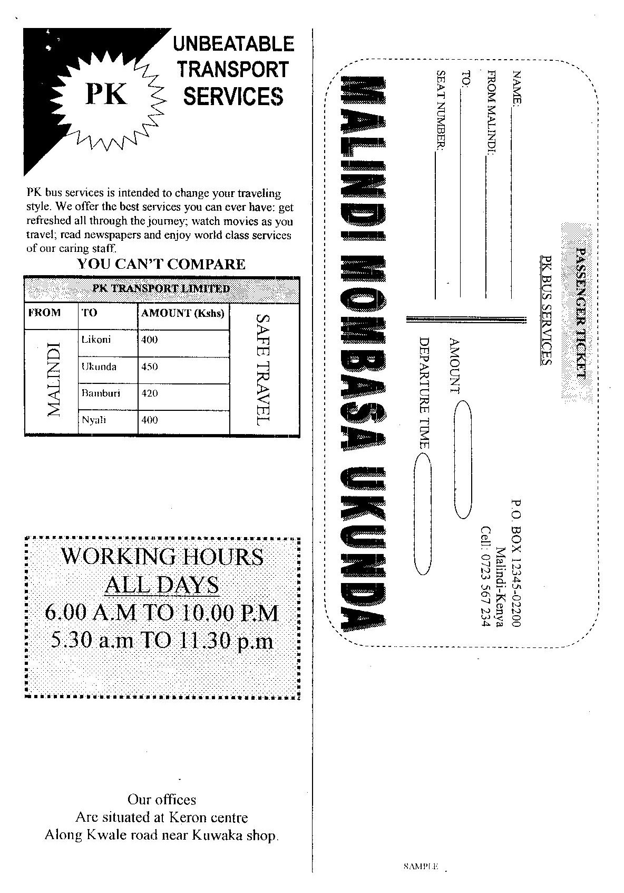
Question 2
Using the spreadsheet application to answer the questions below
 | a | b | c | d | e | f | g | h | i
 |  | Eng | Math | Geo | Comp | Chem | Bio | Average | Grade
1 | Wanjala James | 52 | 25 | 78 | 58 | 89 | 45
2 | Maina John | 89 | 25 | 96 | 87 | 36 | 65
3 | Onyango James | 90 | 41 | 100 | 68 | 85 | 36
4 | Obura Martin | 20 | 52 | 58 | 50 | 70 | 60
5 | Wasike Joseph | 30 | 62 | 42 | 78 | 45 | 54
6 | Mayende Tom | 12 | 45 | 35 | 25 | 41 | 10
7 | Subject mean
8 | Subject Grade
9
 | Class mean

- Enter the data in a work s`heet as it is and save as “RAW DATA” (10 mks)
- Give the worksheet the header as “CAT 1 TERM 2 2009”
Font size 14, underline, bold, font type Tahoma (5 mks)
- Perform the following calculations using formulae’s
- Subject mean (5 mks)
- Average score per student, grade students AND subjects basing on the following criteria, by applying IF function
85 – 100 A
75 – 84 A-
65 – 74 B+
50 – 64 C
Below 50 C- (10 mks)

- Perform the following (10 mks)
  - Change average score per student and average score per subject to zero decimal place
  - Bold and center all the average scores per student
  - Format all subject labels to 45 degrees alignment
  - Rename the sheet as mock
  - Insert the footer “HARD WORK AND SUCCESS ”
- Centre and bold all the grades then rank students from top using average score (6 marks)
- Save as FINAL DRAFT and PRINT IT (4 marks)

