NAKURU DISTRICT JOINT KCSE TRIAL EXAMINATION-2016
451/1
COMPUTER STUDIES (THEORY)
Paper 1
MARKING SCHEME

1. - It require well trained expertise which may not be available
- Crimes constantly change
- Some leave no evidences
- Some crimes can not be linked to an individual or organization.
2. - Ring topology – all devices are connected to one another in the shape of a closed loop
- Star topology : all devices are connected to a central hub.
3. - Lack of trained personnel
- Some areas are not connect to power supply
- Lack of enough funds to purchase ICT equipments
4. It condition in which a person becomes psychological immersed in an artificial environment generatal by a computer system.
5. - Set of rules and procedures that govern communication between two different devices or
people.
- Is any devices that can be configured to provide access to WAN or internet
- Maximum amount of data that a transmission medium can carry, at any one time.
6. - Has icons representing commands
- Provide help
- Has common menu like file, view, etc
- Does not keep user for long without explanation
- Free from bugs.
- meet all user’s requirements
7. - Easy to develop dures that use binary language
- Simplify technology for developing hardware and soft ware
- Digital devices are reliable
- Digital devices are small in size
8. - Bachelor or science in computer engineering
- Bachelor of science in computer science
- Bachelor of science in ICT
- Bachelor of science in software engineering
9. Sorting – arrangement of data in descending or ascending order
Filtering – hiding of column or rows in worksheet.
Or displaying data that meet a certain criteria
10. - System consists of related independent entities that work together to achieve a stated goal
- Information system is an arrangement of people, data processer and information that work together to support and improve the day –to- day operations in a business and the decision making process.
11. i) 76 CD₁₆
7 0111
6 0110
C 1100
D 1101
76CD₁₆ = 0111011011001101₂
ii) 123₈
- 001
2 010
3 011
123₈ = 001010011₂
12. - DRAM memory chip offer more capacity, and are cheap but slower than SRAM.
- SRAM cost more than DRAM but has higher level of performance.
13. - Unshidded twisted pair
- Shielded twisted pair
14. - Master files – main file containing permanent records
- Transaction files- contain individual data about transactions
- Reference file – Used for look- up purpose
- Backup files - hold duplicate copies for security
- Sort files – Created from existing files by arranging data
15. - Icons for commands
- Wireless communication (LAN)
- Voice recognition
- Multimedia e.g video player. Mp3 player
- Java applications
16. a) - Language processor such as assemblers, interpreter and compliers that convert the
sources code into object node.
b) Assembler – translate assembly language into machine language
Interpreter- translate source code line – by – line allowing CPU to execute one line
before translating the next.
Complier – translate entire source code into object code.

c)
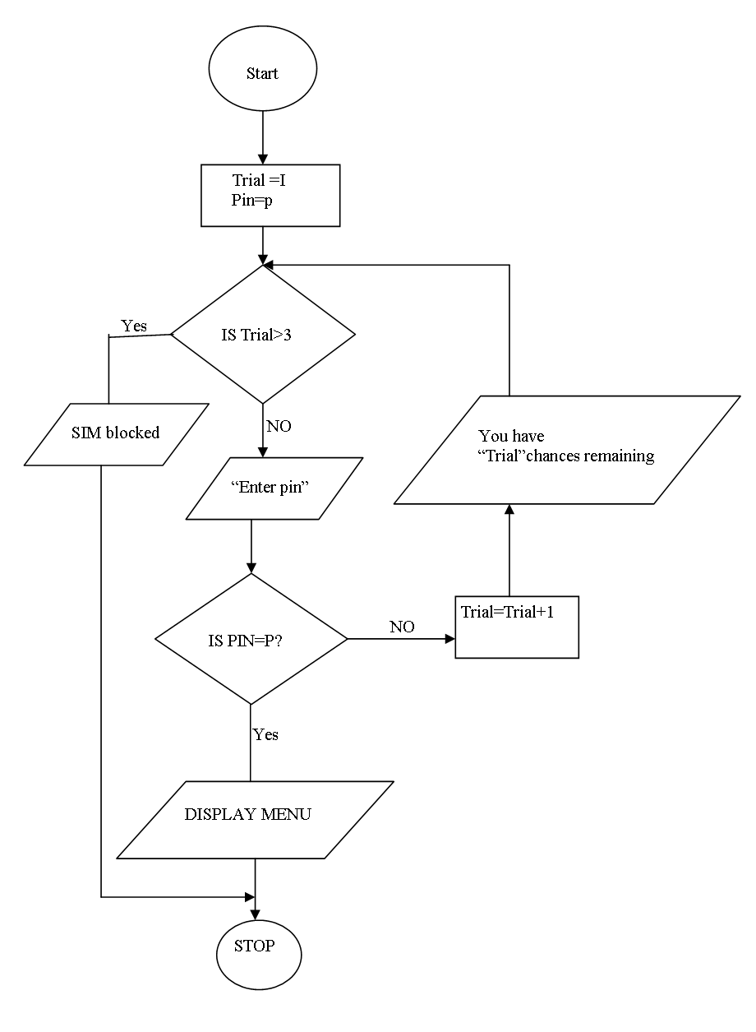

d) Object code – refers to the progion code that is in machine readable form
Source code – program code entered in program editor and is human readable
17. a) Data and information should be vaest secure against loss or exposure
- Data should be transferred to other countries without owner’s permission
- Data and information should be accurate and upto date.
- Data and information to be collected for use should be kept for specified
lawful purpose.
b) - Viruses – destructive programs that attached itself to other files and instales itself
without owner permission
- Unathorised access – gainging acess to data or information without permission
intentionally or accidentally
- Complier errors- caused by people making mistakes when using a program or
developing a program
- Theft – stealing of data and information or computer hardware for a gain
- Natural disasters – such as stoms, volcanicity or earth quakes that destroy computer systems.
c) - Check mails
- Compose message
- Send mail
- Saving messages
- Printing mails
- Cultural erosion
- Fraud e.g stealing of credit card number
- Spread of malicious softwares e.g viruses and warms
18. a) - Process of transforming raw data into meaning output
b) - Wrong entry of data
- Wrong dates types
d) i) Multiprocessing- processing more than one task at the same time on different
processors of the same computer
ii) Multiprograming – More than one program are executed apparently at the same
time by a single processor
iii) Realtime – involves processing of incoming data as soon as it occurs, up – data the transaction file and gives an immediate response that would affect the current as they happen.
iv) Online processing- data is processed immediately it is received
19. a) - Use of electronics devices and software to emulate the neurological structure of the
human brain.
b) - Neuronodes can be trained to distinguish between what constitutes what
constitutes a signal and what does not.
- are capable of recogning patterns in large amount of data that are too complex for human brain.
c) CVS- is a eye health problem associated with using computer screens with unsuitable screen resulation and at a very close range to the eye.
RSI – injuries resulting from wrist, hard, arm and muscle strain, tendonitis and neck strain due to force repetitive movement
d) EPA- encourage use of devices that saves energy through minimal use of power.
e) - Job creation – new employment opportunities that never existed before
- Job replacement – computer illiterate people have been replaced with those who
have desired computer skills
- Displacement – employee moved to another department where computer skills are not required.
f) - Revising current information system and making recommendations on her to
replace it with a more efficient one.
- Working with programmes to construct and test the system
- Co- ordinating training for users of the new system
- Project leader
20. - ASCII
- BCD
- EBCDIC
b) i) 101.001₂
Whole part ⇒( 1 x $\overset{0}{2}$) + ( 0 ×2¹) + ( 1 x 2³) = 1 + 0 + 8 =9
Fraction part ⇒ ( 0 x ‾2¹) + ( 0 x 2⁻²) + ( 1 x 2³) = 2⁻³ = 0.125
∴ 101.001₂ = 9.125₁₀
ii) 12 ⇒ 2⁴2³2²2¹2⁰
12-16-12-8- 4 -4 0-2 0-1 = 0.1100₂
0 1 1 0 0

0.6875 x 2 = 1
0.375 x 2 = 0
0.75 x 2 = 1
0.5 x 2 = 1
= 12.6875₁₀ 1100.1101₂
iii) 110011.0101
110.0100²₂
11111.1001₂

d) 13₁₀ to binary
13 – 16 13 – 8 5 – 4 1 – 2 1-1
6 1 1 0 1
13₁₀ = 01101₂ 8-bit 00001101₂
10₁₀ to binary

10 – 16 10 – 8 2 – 4 2 – 2 0 – 1
0 1 0 1 0

$\begin{matrix}\text{10} \\ \text{10}\end{matrix}$ =01010₂ 8-bit 00001010₂
Ones complement of 00001010₂ 11110101₂
Two’s complement 11110101₂
+1
11110110₂

13₁₀ + (-10₁₀) = 00001101₂
+ 111101101₂
- 00000101₂
= 00000101₂

