TERM 3-2016 OPENER EXAM
FORM 2, COMPUTER STUDIES
TIME: 1 ½ HOURS

INSTRUCTION

- Answer ALL the questions in the answer sheets provided.

1. What is ABACUS? (1 mark)
…………………………………………………………………………………………………
…………………………………………………………………………………………………
2. Give four features attributed to mainframe computers (2 marks)
…………………………………………………………………………………………………
…………………………………………………………………………………………………
…………………………………………………………………………………………………
…………………………………………………………………………………………………
3. Distinguish between the following: (2 marks)
(a) OMR and OCR
…………………………………………………………………………………………………
…………………………………………………………………………………………………
…………………………………………………………………………………………………
…………………………………………………………………………………………………
(b) Power cables and Interface cables (2 marks)
…………………………………………………………………………………………………
…………………………………………………………………………………………………
…………………………………………………………………………………………………
4. Outline four features of alphanumeric keys (4 marks)
…………………………………………………………………………………………………
…………………………………………………………………………………………………
…………………………………………………………………………………………………
…………………………………………………………………………………………………
4. Differentiate between the following Ms Word terms: (3 marks)
(a) Hanging indent and Full indent
………………………………………………………………………………………..
(b) Save and Save As
………………………………………………………………………………………..
………………………………………………………………………………………..
(c) Insert mode and Type over mode
5. Define the following terms (5marks)
(a) Proofreading

(b) Alignment

(c) Right alignment

(d) Left alignment

(e) Justification

6. (a) What is a file? (1mark)
………………………………………………………………………………………..
………………………………………………………………………………………..
………………………………………………………………………………………..
………………………………………………………………………………………..
(b) Give two differences between a file and a folder (2marks)
………………………………………………………………………………………..
………………………………………………………………………………………..
………………………………………………………………………………………..
………………………………………………………………………………………..
7. (a) What is a spreadsheet? (1mark)
………………………………………………………………………………………..
………………………………………………………………………………………..

(b) What are four advantages of using word processor (4marks)
………………………………………………………………………………………..
………………………………………………………………………………………..
………………………………………………………………………………………..
………………………………………………………………………………………..
8. a) What is a section break as used in word processing? (1mk)
……………………………………………………………………………………………………
……………………………………………………………………………………………………
b) State two section breaks that can be used in a word processor (2mks)

9. Distinguish between Job scheduling and job sequencing (2mks)
……………………………………………………………………………………………………
……………………………………………………………………………………………………
10. The diagram below represents a set of keys on the computer keyboard. Study it and use it to answer the
questions that follow
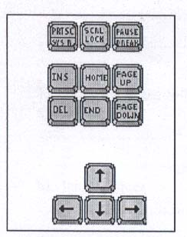
a) Give the appropriate name given to the first set of keys in the diagram (1mk)
……………………………………………………………………………………………………
……………………………………………………………………………………………………
b)State what the following key combination will do when pressed in Microsoft word 2003
i). CtrI + END (1mk)
……………………………………………………………………………………………………
ii). Ctrl + DEL (1mk)
……………………………………………………………………………………………………
11. Distinguish between central processing unit (CPU) and microprocessor (2mks)
……………………………………………………………………………………………………
12. a) State two characteristics of ROM (4mks)
……………………………………………………………………………………………………
……………………………………………………………………………………………………
b) Name two devices other than the typical computer where ROM may be used (4mks)
13. a)Explain the meaning of the following words:
a) Desktop publishing (1 mark)
b) Master page (1 mark)
b) Explain the difference between pasteboard and printable page (2 marks)

14. a) What is meant by disk defragmentation? (2mk)
……………………………………………………………………………………………………
……………………………………………………………………………………………………
b) State the purpose of disk defragmentation (2mks)
……………………………………………………………………………………………………
……………………………………………………………………………………………………
15. List two devices that use micro-electronics in their operations (4mks)
…………………………………………………………………………………………………
…………………………………………………………………………………………………
16. a) Name two ways in which data can be input into a computer, and state the device
that can be used in each case. (2mks)
…………………………………………………………………………………………………
…………………………………………………………………………………………………
b) Explain why a buffer is used in the output of data to a line printer (1mk)
…………………………………………………………………………………………………
…………………………………………………………………………………………………
17. What is a peripheral device (1mk)
…………………………………………………………………………………………………
…………………………………………………………………………………………………
18. a) Give two reasons why computers need backing storage (2mks)
…………………………………………………………………………………………………
…………………………………………………………………………………………………
b) For each application, give two features that make a spreadsheet package particularly suitable (2mks)
19. a) List two types of paper orientation (2mks)
…………………………………………………………………………………………………
…………………………………………………………………………………………………
b) Name two keys used to delete text in a document (2mks)
…………………………………………………………………………………………………
…………………………………………………………………………………………………
20. a)Identify two different applications in a school that might be implemented by using a spreadsheet
package (2mks)

21. a) Write the following statement “mock examinations” in (2mks)
i. Title case………………………………………………………………………………
ii. Toggle case……………………………………………………………………………
b) State when the following mouse shapes appear in an excel worksheet (2mks)

+ ………………………………………………………………
………………………………………………………….........
22. Define the following terms (4mks)
a) Digital data
…………………………………………………………………………………………………………
………………………………………………………………………………………………………
b) Analogue data
……………………………………………………………………………………………………………………………………………………………………………………………………………………………….
23. a) What is a hard copy (lmks)
……………………………………………………………………………………………………………………………………………………………………………………………………………………………….
b) State two reasons why hardcopy output is still very necessary today (lmk)
……………………………………………………………………………………………………………………………………………………………………………………………………………………………….
24. A form four student tried to save his project from a hard disk to a CD but was not successful. List
three possible causes of the anomaly. (3mks)
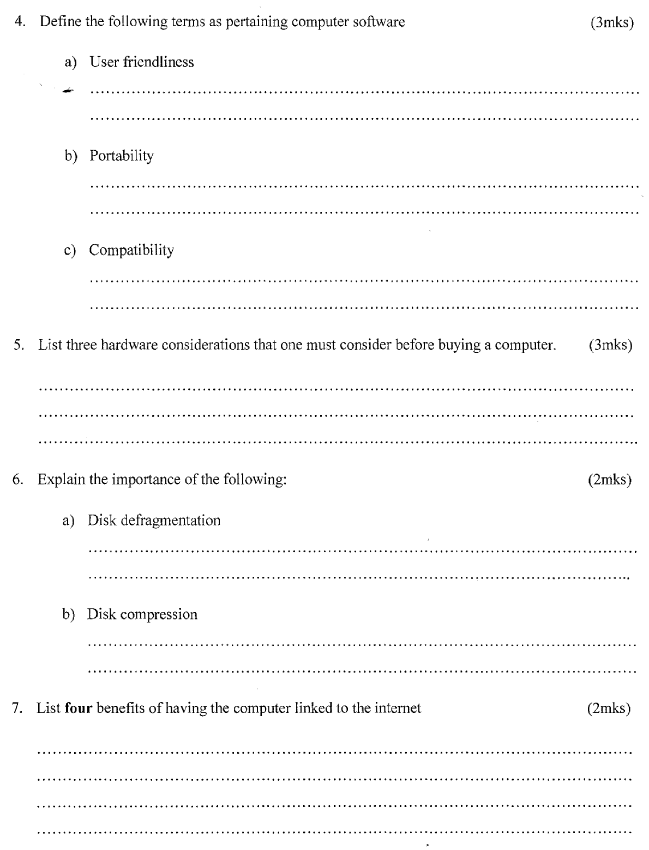
……………………………………………………………………………………………………………………………………………………………………………………………………………………………….……………………………………………………………………………………………………………………………………………………………………………………………………………………………….

25. Define the following terms as pertaining computer software (3mks)
a) User friendliness
b) Portability

c) Compatibility
26. Explain three hardware considerations that one must consider before buying a computer. (3mks)
………………………………………………………………………………………………………………………………………………………………………………………………………………………………………………………………………………………………………………………………………………………………………………………………………………………………………………………………

27. Explain the importance of the following: (2mks)
a) Disk defragmentation
………………………………………………………………………………………………………………………………………………………………………………………………………………………………
b) Disk compression
………………………………………………………………………………………………………………………………………………………………………………………………………………………………
30. Differentiate between the following terms:
i) Proofreading and thesaurus (4 marks)
………………………………………………………………………………………………………………………………………………………………………………………………………………………………………………………………………………………………………………………………………………………
ii) Autocomplete and autocorrect (4 marks)
………………………………………………………………………………………………………………………………………………………………………………………………………………………………………………………………………………………………………………………………………………………

