FORM 1 CHEMISTRY EXAM
TERM II 2013

Name…………………….………..………………………… Class………. Adm: No………………………

1. (a) When the air-hole is closed, the Bunsen burner produces a luminous flame. Explain (2 marks)

………………………………………………………………………………………………………………………………………

………………………………………………………………………………………………………………………………………

………………………………………………………………………………………………………………………………………

(b) Draw a fully labelled diagram of a luminous flame. (4 marks)

(c) List the differences between a luminous and a non-luminous flame. (5 marks)

Luminous | Non - luminous
1 | 1
2 | 2
3 | 3
4 | 4
5 | 5

2. (a) What is a drug? (2 marks)

………………………………………………………………………………………………………………………………………

………………………………………………………………………………………………………………………………………

………………………………………………………………………………………………………………………………………

(b) Name any three frequently abused drugs. (3 marks)

- ……………………………………………………………………………………………………….

- ……………………………………………………………………………………………………….

- ……………………………………………………………….………………………………………

3. Name and state the Use of the laboratory apparatus shown in the diagrams below. (4 marks)

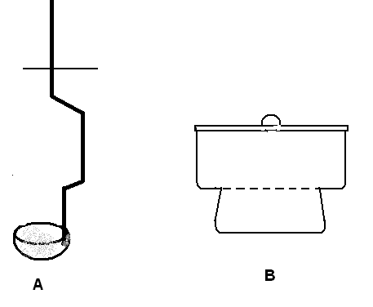

(a) Name of apparatus A ………………………………………………… (1 mark)

(b) Use of the apparatus A (1 mark)

………………………………………………………………………………………………………………………………………

………………………………………………………………………………………………………………………………………

(a) Name of apparatus B ………………………………………………… (1 mark)

(b) Use of the apparatus B (1 mark)

………………………………………………………………………………………………………………………………………

………………………………………………………………………………………………………………………………………

4. Spots of pure pigments A and B, and a mixture Z were placed on a filter paper and allowed to dry .The paper was then dipped in a solvent. The results obtained were as shown on the paper chromatogram.

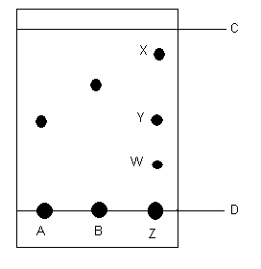

(a) (i) Name C ………………………………………………………………….. (1 mark)

(ii) Name D ………………………………………………………………….. (1 mark)

- Which of the pure pigments was a component of Z? Explain. ( 2 marks)

………………………………………………………………………………………………………………………………………

………………………………………………………………………………………………………………………………………

………………………………………………………………………………………………………………………………………

- (i) Name a solvent that can be used in the paper chromatography. (2 marks)

………………………………………………………………………………………………………………………………………

(ii) Why is water NOT suitable solvent in paper chromatography? (2 marks)

………………………………………………………………………………………………………………………………………

………………………………………………………………………………………………………………………………………

………………………………………………………………………………………………………………………………………

5. Write a word equation for the reaction between the following: (8 marks)

- Carbon and Oxygen

…………………………………………………………………………………………………………………

- Iron and Sulphur

…………………………………………………………………………………………………………………………

- Copper and Chlorine

…………..……………………………………………………………………………………………………………

- Zinc and Sulphuric acid

…………………………………………………………………………………………………………………………

6. (a) Complete the table below on effect of various solutions on indicators? (6 marks)

Indicator | Colour in
Indicator | Base | Neutral | Acid
Methyl Orange |  | Orange
Litmus | Blue |  | Red
Phenolphthalein

(b) What is the main advantage of the Universal Indicator over other acid- base indicators? (2 marks)

………………………………………………………………………………………………………………………………………

………………………………………………………………………………………………………………………………………

………………………………………………………………………………………………………………………………………

(c) List any 3 properties for each of the following: (6 marks)

* Acids

(i)……………………………………………………………………………………………………………………………………..

(ii)…………………………………………………………………………………………………………………………………….

(iii)…………………………………………………………………………………………………………………………………....

* Bases

(i)……………………………………………………………………………………………………………………………………..

(ii)…………………………………………………………………………………………………………………………………….

(iii)…………………………………………………………………………………………………………………………………....

7. (a) Draw the pH scale in the space. (2 marks)

(b) State whether the following solutions are strong acid, weak acid, strong base or weak base: (4 marks)

Toothpaste | Weak Base
Lemon juice

Soap solution

Sulphuric acid

Ammonia solution

8. The figure below shows the heating curve of a pure substance Q. Use it to answer the questions that follow:

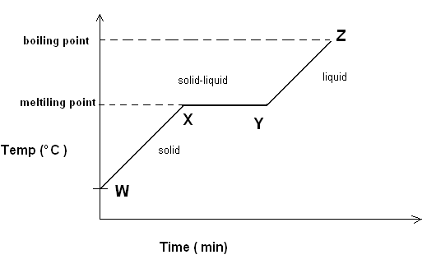

- In terms of Kinetic Theory, Explain what happens at the regions indicated below. ( 9 marks)

(i) Region WX:

………………………………………………………………………………………………………………………………………

………………………………………………………………………………………………………………………………………

………………………………………………………………………………………………………………………………………

(ii) Region XY:

………………………………………………………………………………………………………………………………………

………………………………………………………………………………………………………………………………………

………………………………………………………………………………………………………………………………………

(iii) Region YZ:

………………………………………………………………………………………………………………………………………

………………………………………………………………………………………………………………………………………

………………………………………………………………………………………………………………………………………

- Sketch the Cooling Curve of the pure substance Q on the grid provided below.

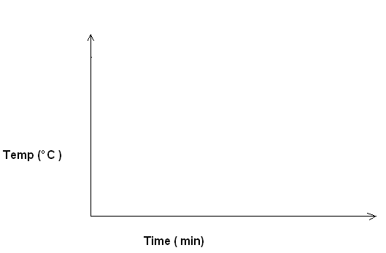

- What is the effect of an impurity on the melting and boiling point of a substance? ( 2marks)

………………………………………………………………………………………………………………………………………

………………………………………………………………………………………………………………………………………

………………………………………………………………………………………………………………………………………

< END >

