Name………………………………………………………. CLASS …………………………….. ADMISSIONNO……………… Date ……………………………..…..
232/2
PHYSICS
FORM THREE PAPER
(Theory)
OCT MID
2 Hours

Kenya Certificate of Secondary Education (K.C.S.E)
232/2
PHYSICS
FORM THREE PAPER
(Theory)
OCT MID
2 Hours

Instructions to Candidates
- Write your name and admission number in the spaces provided above.
- This paper consists of two questions A and B.
- Answer all the questions in section A and B in the spaces provided
- All working MUST clearly be shown in the spaces provided in this booklet.
- Non programmable silent electronic calculators and KNEC mathematical tables may be used except where stated otherwise.
Take: Speed of light in vacuum C = 3.0 x 10⁸m/s

FOR EXAMINER’S USE ONLY

Section | Question (s) | Max. Score | Candidates Score
A | 1 – 12 | 25
B | 13 | 14
B | 14 | 11
B | 15 | 11
B | 16 | 9
B | 17 | 10
B | Total | 80

This paper consists of 8 printed pages. Candidates should check the question
paper to ensure that all the pages are printed as indicated and no questions are missing

SECTION A (25 MARKS)
1. Explain why enlarging the pinhole of the pinhole camera causes the image to be blurred.
(2 marks)
…………………………………………………………………………………………………
…………………………………………………………………………………………………
2. Fig. 1 shows a bar magnet and two points A and B in front of the magnet.
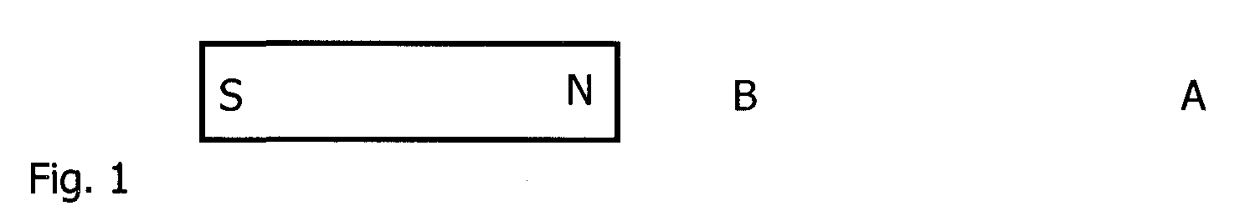

On the axes provided sketch a graph showing how the magnetic field strength changes from
A to B (2 marks)
A Distance B
Magnetic field strength

3. 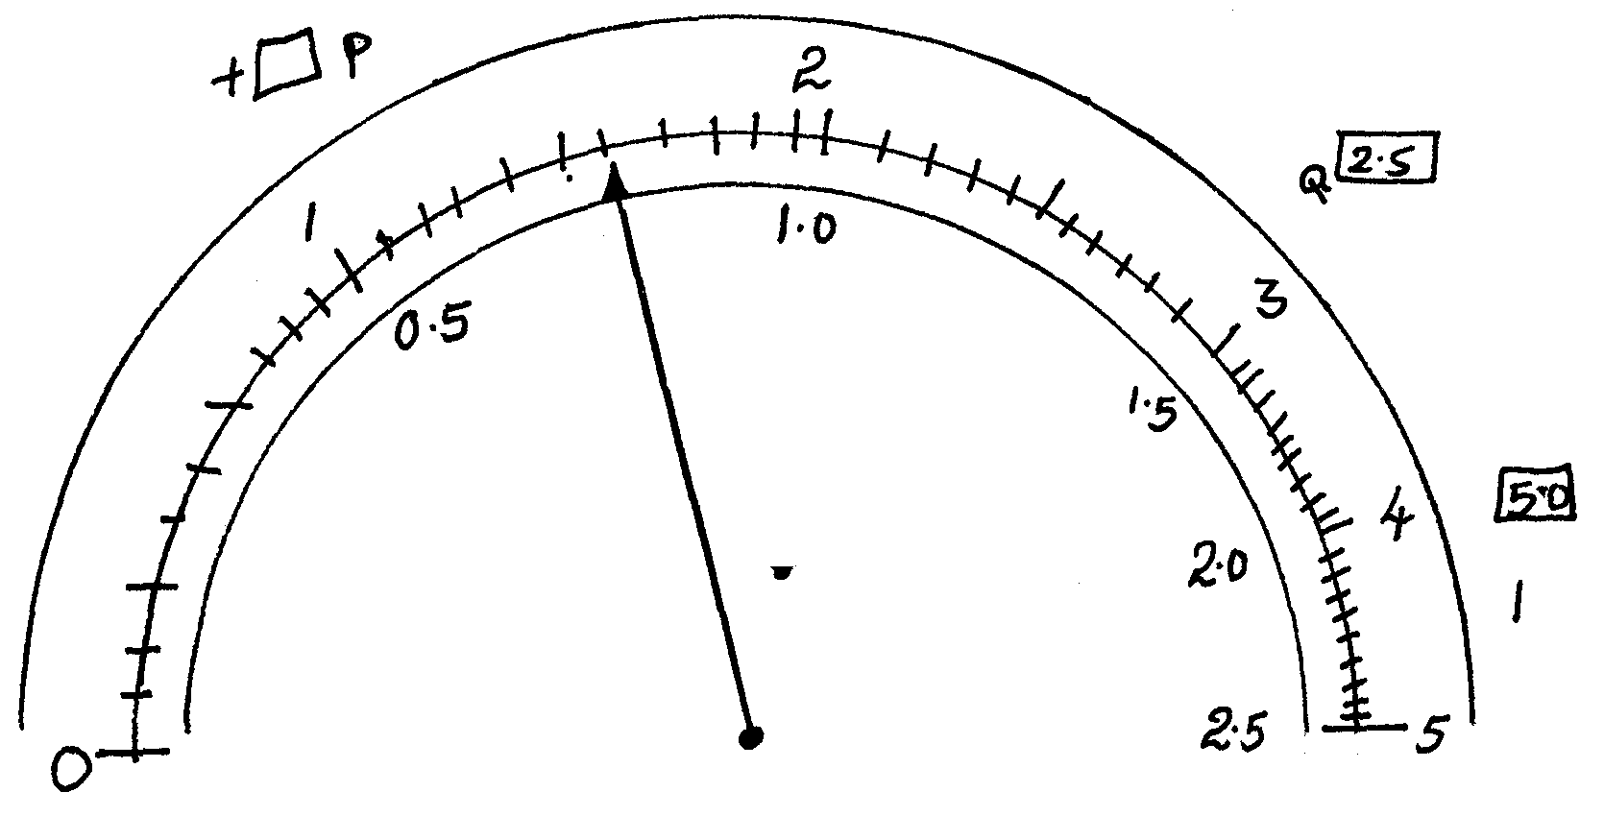
What is the reading indicated by the pointer if terminal of the a battery is connected across a dual scale ammeter. The terminal P is connected to the positive cell while Q is connected to the negative terminal.
………………………………………………………………………………………
…………………………………………………………………………………………………
4. Light is incident on an air-glass boundary at an angle of incidence of 40⁰. If the refractive
index of the glass is 1.7, determine the angle of refraction. (3 marks)
…………………………………………………………………………………………………
…………………………………………………………………………………………………
…………………………………………………………………………………………………
…………………………………………………………………………………………………
5. A luminous point object took 3 sec to move uniformly from P to Q in front of a pin hole camera as shown in figure 3 below
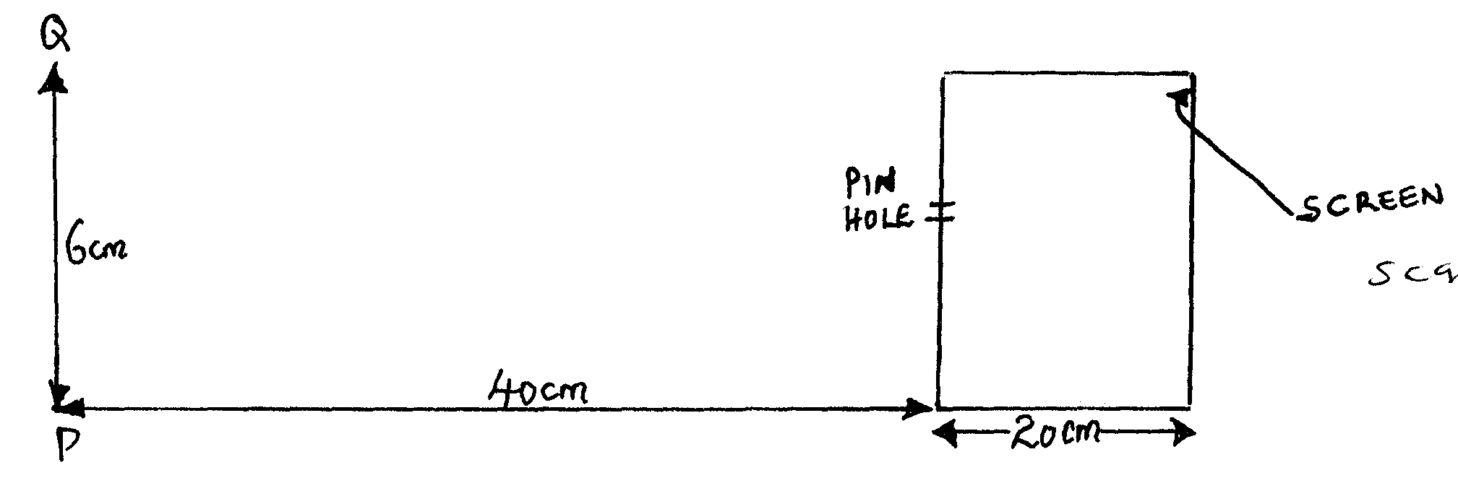

Determine the speed of the image on the screen in cm/s (3 marks)
………………………………………………………………………………………………………………………………………………………………………………………………
…………………………………………………………………………………………………

6. Fig.2 shows an image; I formed by an object placed in front of a convex mirror. C is the
centre of curvature of the mirror.
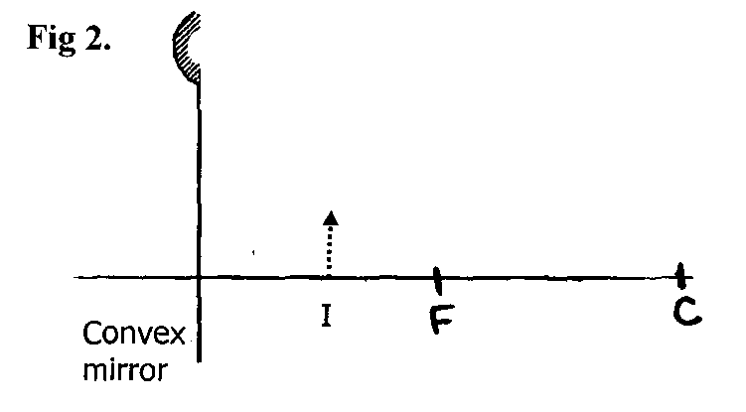
On the diagram draw appropriate rays and locate the position of the object. (3 marks)
7. A wire of resistance X connected in series with a 1.5 V battery is found to carry a current
of 0.075 A. If the wire is now connected in parallel with an identical wire, find the total current in
circuit. (3 marks)
…………………………………………………………………………………………………
…………………………………………………………………………………………………
…………………………………………………………………………………………………
…………………………………………………………………………………………………
8. An object is placed at 2F in front of a converging mirror and its image is observed. State how
the image changes as the object is moved from 2F towards F. (1 mark)
…………………………………………………………………………………………………
…………………………………………………………………………………………………
9 Fig.3 Below shows a velocity time graph for a moving object.
Fig .
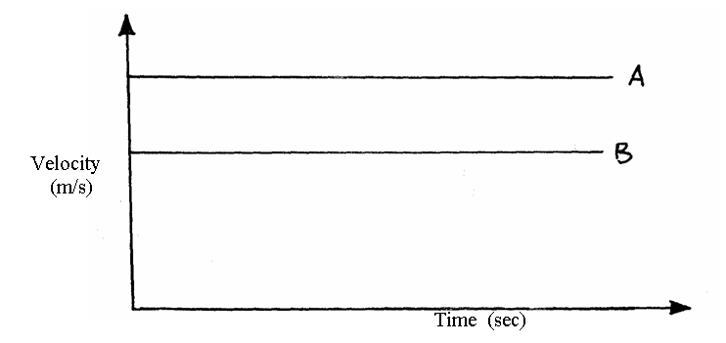
Draw two other graphs on fig above for displacement against time and label them A and B respectively. (2mks)
10. A machine consists of a wheel of radius 40 cm and axle of radius 10cm. Determine its efficiency when used to lift a load of 300N using an effort of 100N (3mks)

11. Fig. 4 shows the profile of a transverse wave.
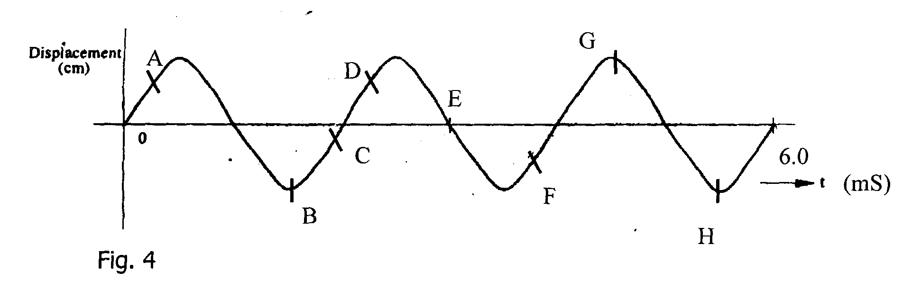
i) Identify two sets of points that represent points that are in phase. (2 marks)
…………………………………………………………………………………………………
…………………………………………………………………………………………………
ii) Determine the frequency of the wave. (3 marks)
…………………………………………………………………………………………………
…………………………………………………………………………………………………
…………………………………………………………………………………………………
…………………………………………………………………………………………………
12. What basic physical quantity can be measured using a simple pendulum (1mk)
……………………………………………………………………………………………………………………………………………………………………………………………………………………

SECTION B (55 MARKS)
13. a) (i) State one property of standing waves. (1 mark)
…………………………………………………………………………………………………
…………………………………………………………………………………………………
ii) With the aid of diagram, explain the lowest possible mode of vibration in closed
pipe. (3 marks)

b) Complete the diagram in Fig. 5 to show the patterns of the waves after passing
through the slits S1 and S₂. (2 marks)
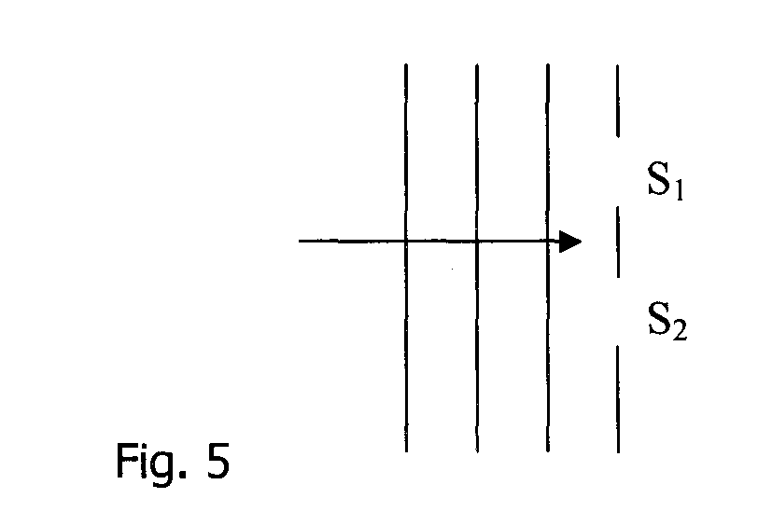
c) Water waves are observed to pass a fixed point at a rate of 60 crests per minute.
A wave crest takes 4.0 seconds to travel between two fixed points 12.0 m apart.
Determine:
i) The velocity ,v, of the waves. (3 narks)
…………………………………………………………………………………………………
…………………………………………………………………………………………………
…………………………………………………………………………………………………
ii) The wavelength, A of the waves. (3 marks)
…………………………………………………………………………………………………
…………………………………………………………………………………………………
…………………………………………………………………………………………………
d) A girl standing in front of a wall 90 m away claps her hands at time intervals of 0.5
seconds. She notices that each echo produced by the wall coincides with the next
clap. Determine the speed of sound. (3 marks)
…………………………………………………………………………………………………
…………………………………………………………………………………………………
…………………………………………………………………………………………………
14.
………………………………………………………………………………………………… a) Define moment of a force (1mk)
……..……………………………………………………………………………………………………
……..……………………………………………………………………………………………………
b) Fig. 11 below shows a uniform bar in equilibrium.
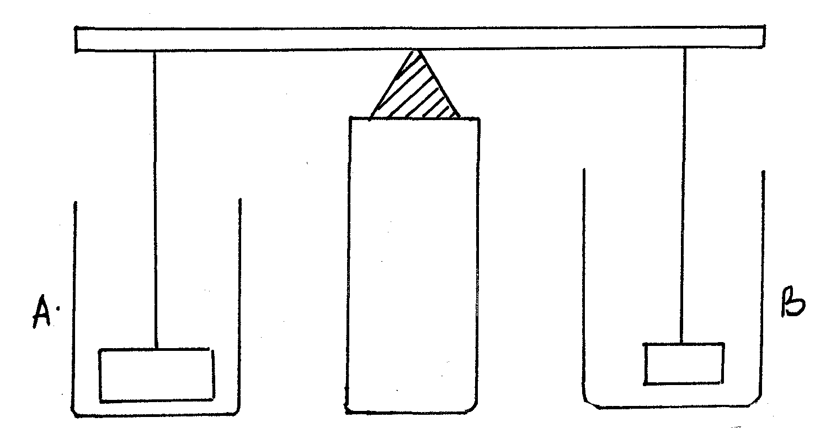

When water is added into the beakers A and B until the weights are submerged, its observed that the bar tips towards B. Explain this observation. (2mks)
………….………………………………………………………………………………………………
………….………………………………………………………………………………………………
……..……………………………………………………………………………………………………
……..……………………………………………………………………………………………………
c) A uniform metre rule of uniform width 2.5cm and thickness 0.5cm. Fig 12 below, is suspended at the 80cm mark and kept balanced by hanging a mass of 150g at 100cm mark.
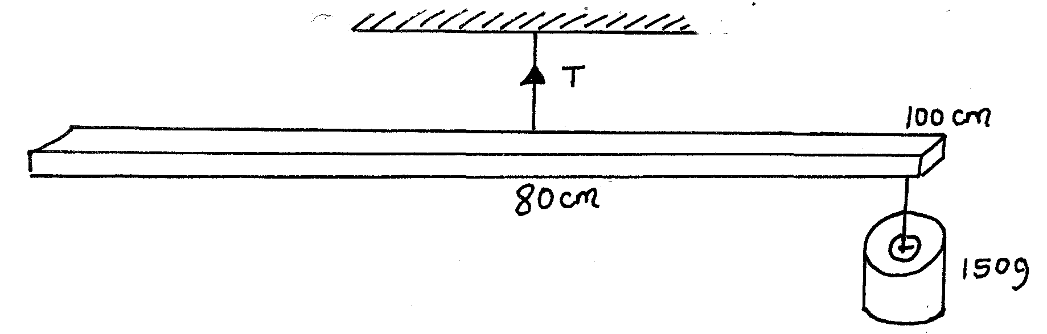
Calculate.
i) The mass of the metre rule. (3mks)

ii) The density of the material of the metre rule. (3mks)

iii) The tension T in the string. (2mks)

15. a) The table 1 below has a data recorded for a compressional force on a spring balance.
Force F (N) | 0 | 5.0 | 10.0 | 15.0 | 17.5 | 22.5 | 35.0 | 40.0 | 45.0 | 50
Length of spring L (cm) | 16.5 | 15.0 | 13.5 | 12.0 | 11.6 | 9.75 | 8.25 | 8.00 | 8.00 | 8.00
Compression of spring $ℓ$ (cm)
i) Complete the table for the values of compression (e) (2mks)

ii) Plot a graph of extension (vertical axis) versus force applied on the spring (horizontal axis).
(5mks)

b) From your graph determine.
i) The spring constant K. (2mks)

ii) Work done in compressing the spring until the coils just come into contact. (2mks)

16. a) Figure 13 below shows a tape made from a ticker tape timer running at 50Hz.
Fig 13.
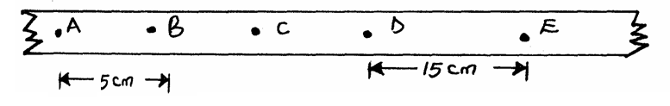
Find,
i) The time taken for one tick interval (1mk)

ii) Velocities between points AB and DE (3mks)

iii) Acceleration of the body over interval AE (2mks)

b) A girl dropped a stone from the top of a tower 45m tall and a boy projected another stone vertically upwards at 25m/s at the same time. Determine the time taken for the two stones to meet.
(3mks)

END
17.(a) State the ohms law. (1 mk)

(b) Describe a laboratory experiment to verify ohm’s law, by use of appropriate diagrams where necessary. (5 mks)

c. The figure below shows a battery of negligible internal resistance. Two resistors, a capacitor, a voltmeter and a switch are connected as shown.

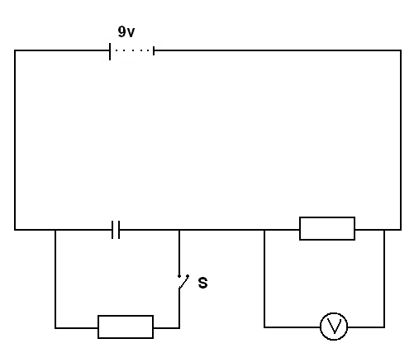
3Ω
3Ω

Giving a reason for your answer in each case, state the readings on the voltmeter V when the switch is
(i) Open (2 mks)

V =

Reason

(ii) Closed (2mks)
V =

Reason –

Using the graph, determine:
i) The half life of the radioisotope (2 marks)
…………………………………………………………………………………………………
…………………………………………………………………………………………………
…………………………………………………………………………………………………
iii) How long it would take the count rate to fall from 320 to 40 counts s⁻¹ (2 marks)
…………………………………………………………………………………………………
…………………………………………………………………………………………………
…………………………………………………………………………………………………
16. a) A driver observes that when he alights from the car, while touching its
body he receives an electric shock. While inside there is no effect even he touches the
car. Explain these observations. (2 marks)
…………………………………………………………………………………………………
…………………………………………………………………………………………………
…………………………………………………………………………………………………
b) State two factors other than area of overlap of the plates that are considered
when constructing a parallel plate capacitor. (2 marks)
…………………………………………………………………………………………………
…………………………………………………………………………………………………
…………………………………………………………………………………………………
c) Fig. 6 represents a circuit which is used to charge a 20 µF capacitor by connecting it
to a 15 V battery. Later the capacitor is connected to a 10 µF capacitor.
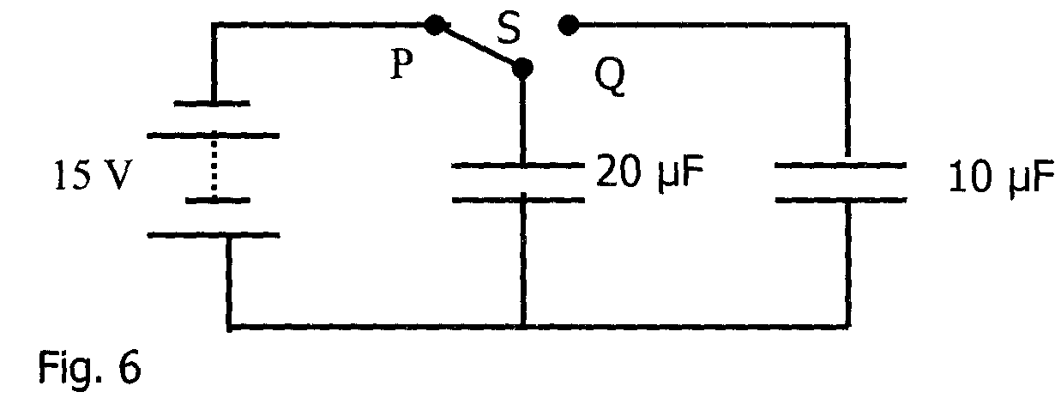
i) Switch S is first closed at position P so that the 20 µF capacitor charges. Find
the maximum charge stored. (3 marks)
…………………………………………………………………………………………………
…………………………………………………………………………………………………
…………………………………………………………………………………………………

ii) The switch S is now moved to Q. Determine the final potential difference, V
across the capacitors. (3 marks)
…………………………………………………………………………………………………
…………………………………………………………………………………………………
…………………………………………………………………………………………………
17. a) i) Explain how P -type semiconductor is made from a pure semiconductor
crystal. (3 marks)
…………………………………………………………………………………………………
…………………………………………………………………………………………………
…………………………………………………………………………………………………
ii) What are the majority charge carriers in a p-type semiconductor? Explain. (2 marks)
…………………………………………………………………………………………………
…………………………………………………………………………………………………
…………………………………………………………………………………………………
…………………………………………………………………………………………………
…………………………………………………………………………………………………
…………………………………………………………………………………………………
b) Fig. 7 show the N- pole of a bar magnet approaching an aluminium ring. The ring moves
away from the magnet.
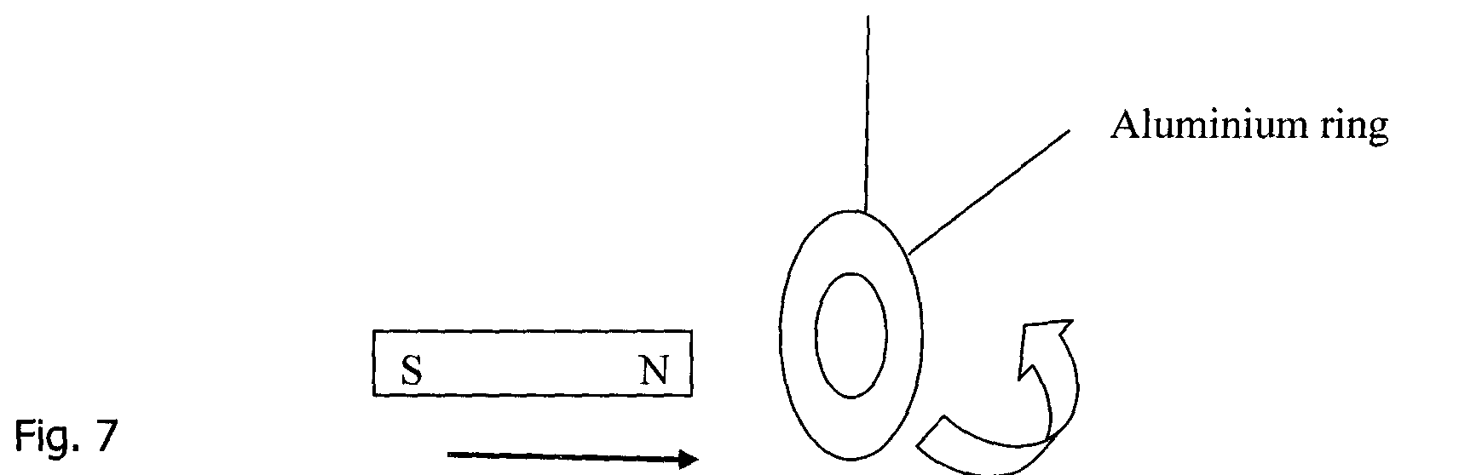
i) Indicate on the ring the direction of the induced current. (1 mark)
ii) Explain why the ring moves away. (3 marks)
…………………………………………………………………………………………………
…………………………………………………………………………………………………
…………………………………………………………………………………………………

END

