KCSE ONLINE REVISION
END OF TERM 1 2013
GEOGRAPHY FORM 2
Answer all questions in the spaces provided .
Qn1(a) Give four significance studying geography in schools. (4mks
(i)

(ii)

(iii)

(iv)

(b) Show the relationship between geography and mathematics. (2mks

Qn2(a) Identify two forces that give the earth its shape. (2mks)

(b) The diagram below shows the internal and external structure of the earth.
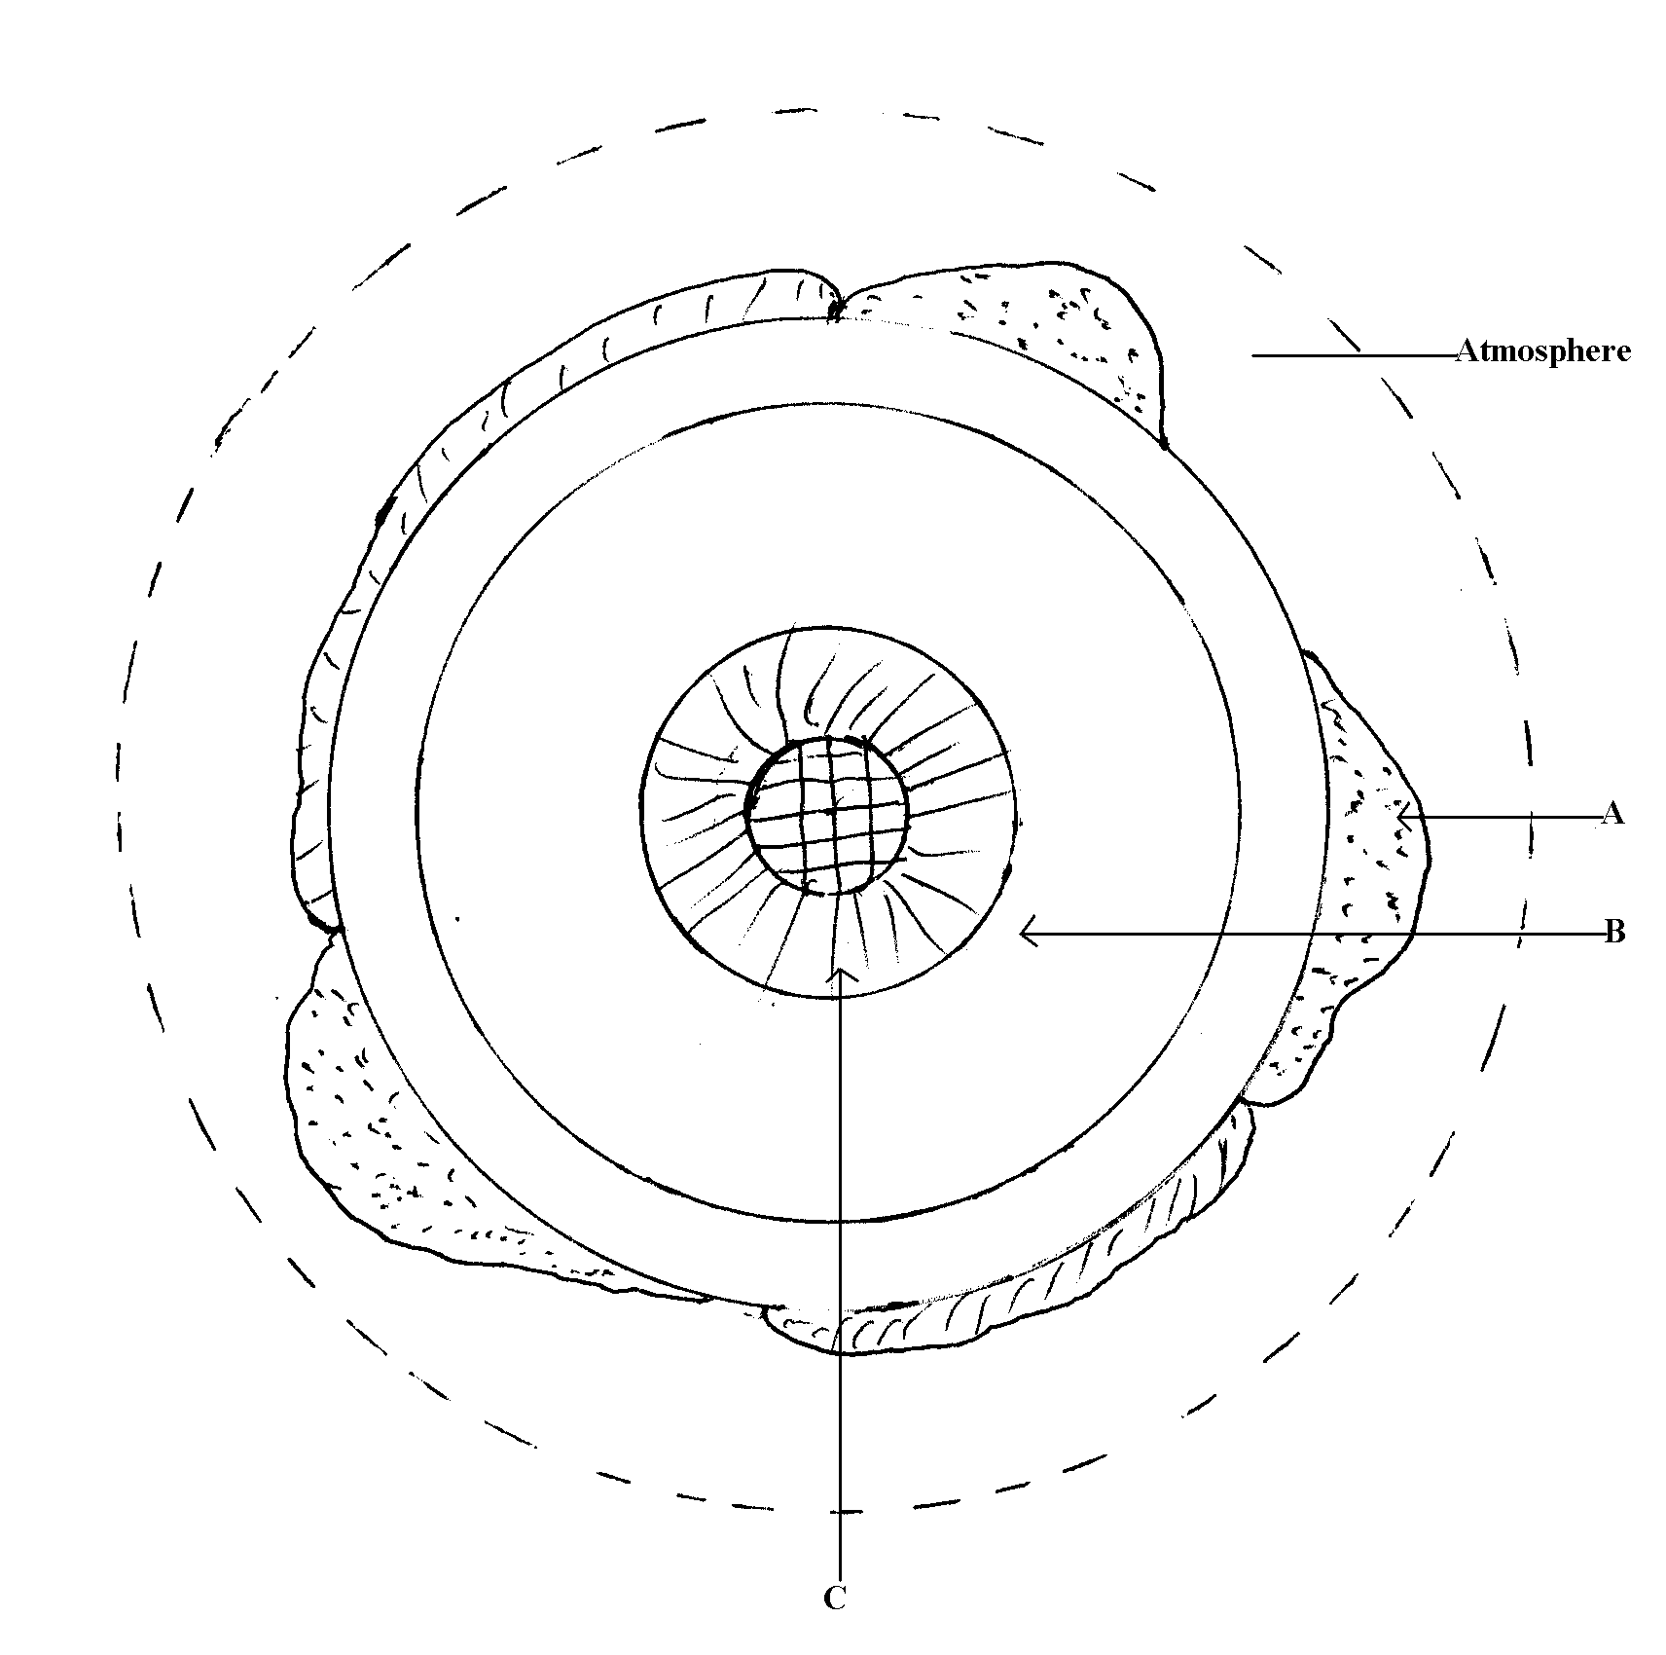
Name the parts marked A, B and C. (3mks

Qn3(a) State two conditions necessary for formation of a fog. (2mks

b) State three factors that determine the amount of solar radiation which reaches the surface of the earth. (3mks

Qn4(a) a) Give two weaknesses of the passing star theory. (2mks

b) State two characteristics of the mantle. (2mks)

©Name three types of boundaries associated with plate tectonic movements. (3mks)

Qn5(a) Distinguish between a mineral and a rock (2mks

(b) Give five characteristics of minerals (5mks

Qn6(a) apart from igneous rocks name two other types rocks according the classification based on mode of formation. (4mks
(i)
(ii)
(b) Describe the following types of rocks.
(i) volcanic rocks. (3mks

(ii) plutonic rocks. (3mks

Qn7(a) Identify five factors tha influence the rate of metaforphism. (5mks

(b) Give the three main types of rocks metamorphism. (3mks

Qn8(a) Name four types of underground mining. (4mks
(i)

(ii)

(iii)

(iv)

(b) Explain six significance of mining to Kenyan economy. (12mks
(i)

(ii)

(iii)

(iv)

(v)

(vi)

(c) Identify four negative effect of mining to the environment. (4mks
(i)

(ii)

(iii)

(iv)

Qn9(a) Write four contribution of gold mining in South Africa. (4ms
(i)

(ii)

(iii)

(iv)

(b) Give four prolems facing gold mining in South Afr ica. (4mks
(i)

(ii)

(iii)

( iv)

Qn10(a) Difine the term earth movement. (2mks

(b) Mention two ty pes of earth movement. (4mks
(i)

(ii)

© Give four causes of earth movement. (4mks
(i)
(ii)
(iii)
(iv)

Qn11(a) briefly describe the theory of continental drift. (6mks

(b) State five evidence of continental drift theory. (5mks
(i)

(ii)

(iii)

(iv)

(v)

© Give three forces shaping the earth from inside. (3mks

