Form 2 Chemistry
End Term Exam Term I 2013

Name……………..…………………………….……………….. Adm: …………..………… Class…………….

Answer all the questions in this paper in the spaces provided ONLY
1. An atom of sodium is represented as:
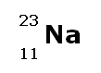
- Calculate the number of neutrons in the nucleus of a sodium atom. [1 mark]
...……………………………………………………………………………………………………………..
………………………………………………………………………………………………………………..
………………………………………………………………………………………………………………..
- Write the electronic configuration of a sodium atom. [1 mark]
...……………………………………………………………………………………………………………..
- State ;
  - the group to which sodium belongs [1 mark]
...……………………………………………………………………………………………………………..
  - the period to which sodium belongs [1 mark]
...……………………………………………………………………………………………………………..
2. Study the grid below which represents part of the periodic table and then use it to answer the questions that follow. The letters are not actual symbols of the elements.

A
 |  |  |  |  |  |  | B
 | B |  |  |  |  | E | F
G

- Select the most reactive non-metal [1 mark]
...……………………………………………………………………………………………………………..
- Select the most reactive metal [1 mark]
...……………………………………………………………………………………………………………..
- An element that can form an ion with a charge of +2 [1 mark]
...……………………………………………………………………………………………………………..
- An element that can form an ion with a charge of -1 [1 mark]
...……………………………………………………………………………………………………………..

- The setup below was used to study the properties of air
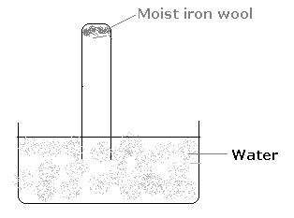

(a) State two observations made at the end of the experiment. [2 marks]
(i) ...……………………………………….……………………………………………………………………..
……………………………………………………..……………………………………………………………..
(ii) ...……………………………………………………………………………………………………………..
…………………………………………..………………………………………………………………………..

(b) List two simple methods that can be used to prevent rusting. [2 marks]
(i)...………………………………………………………………………………………………………………..
(ii)………………………………………………………………..………………………………………………..

4. When anhydrous copper (II) sulphate is left in the open overnight, it’s colour changes to blue. Explain [1 mark]
...…………………………………………………………………………………………..…………………………..
…………………………………………………………………………….…………………………………………..
……………………………………………………………………….………………………………………………..

5. Complete the word equation shown below: [1 mark]
(a) Lead (II) Oxide + Carbon ------→ +
(b) Which of the reagents in (a) above is:
(i) An oxidising agent ……………………………..…………………………………… [1 mark]
(ii) A reducing agent ……………………………………………………………………. [1 mark]

6. (a) In the lab preparation of oxygen from hydrogen peroxide, what role is played by manganese (VII) oxide? [1 mark]
...……………………………………………………………………………..……………………………………..
………………………………………………………………..……………………………………………………..
………………………………………………………….…………………………………………………………..

(b) Explain how oxygen is tested [1 mark]
...……………………………………………………………………..………………………………………………..
…………………………………………………………………………….…………………………………………..

(c) Write the word equation of the reaction that occurs when cold water is added to sodium peroxide.
...…………………………………………………..…………………………………………………………………..
……………………………………………….………………………………………………………………………..

7. The set-up below was used to investigate the effect of steam on magnesium metal.

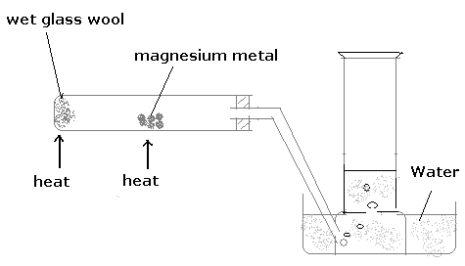

- Explain the observation made inside the gas jar at the end of the experiment [2 marks]
...……………………………………………………………….…………………………………………………..
……………………………………………………….……………………………………………………………..
………………………………………………………….…………………………………………………………..

- Explain why it necessary to heat the wet glass wool first before heating the magnesium metal [2 marks]
...……………………..……………………………….…………………………………………………………..
…………………………….………………………….…………………………………………………………..
…………………………….…………………………….………………………………………………………..

8. An element P has mass 39 and 20 neutrons.
(a) Calculate the number of electrons of the atom P [1 mark]
...………………………………………………………………..……………………………………………………..
……………………………………………………………..…………………………………………………………..

(b) Draw the atomic structure of element P using crosses (x) to represent electrons in the space provided below. [2 marks]

(c) Which period does element P belong ? [1 mark]
...…………………………………………………………………………….………………………………………..

9. Write balanced equations for the reactions shown below; [8 marks]
(a) Heating sodium metal in oxygen
...……………………………………………………………………………………………………………..
………………………………………………………………………………………………………………..
(b) Copper (II) oxide reacting with hydrogen
...……………………………………………………………………………………………………………..
………………………………………………………………………………………………………………..
(c) Sodium metal reacting with water
...……………………………………………………………………………………………………………..
………………………………………………………………………………………………………………..
(d) Reaction of dilute hydrochloric acid with zinc granules
...……………………………………………………………………………………………………………..
………………………………………………………………………………………………………………..

10. A sample of chlorine gas contains the isotopes Cl-35 (75%) and Cl–37 (25%)
(a) What are isotopes? [2 marks]
...……………………………………………………………………………………………………………..
………………………………………………………………………………………………………………..
………………………………………………………………………………………………………………..

(b) Calculate the relative atomic mass of chlorine [3 marks]
...……………………………………………………………………………………………………………..
………………………………………………………………………………………………………………..
………………………………………………………………………………………………………………..

(c) An element X has 3 isotopes with mass number 22, 24 and 25 in the ratio 2:3:1 Calculate its relative atomic mass. [3 marks]
...………………………………………………………………..…………………………………………………..
…………………………………………………………….………………………………………………………..
………………………………………………………….…………………………………………………………..

11. Name the following gas collection methods; [3 marks]
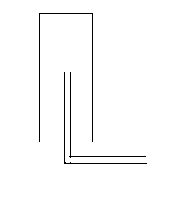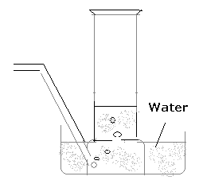
(i) ……………..…………………………. (ii) ……………….……..…………………… (iii) …………..………………………

12. (a) What is a flame? [1 mark]
...……………………………………………….………………………………………………………………………..
………………………………………………………….………………………………………………………………..

(b) Name the type of flame shown below …………………………….………………………………… [1 mark]

- Label the zones A, B and C [3 marks]

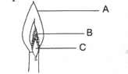

- Zone A ……………………………………..……………………….
- Zone B ………………………………………..…………………….
- Zone C ……………………………………………………………….

