NAME………………………………………………………………….ADM NO……………CLASS………
231/2
Biology

FORM 3 BIOLOGY

INSTRUCTIONS
This paper consists of 2 sections a and B
Answer all questions in section A
In section B answer either question 17 or question 18.

SECTION A
1. State the functions of the following cell organelles: (2 marks)
(a) Nucleolus.

(b) Plasma membrane

2. An experiment was set-up as shown below and left for one hour
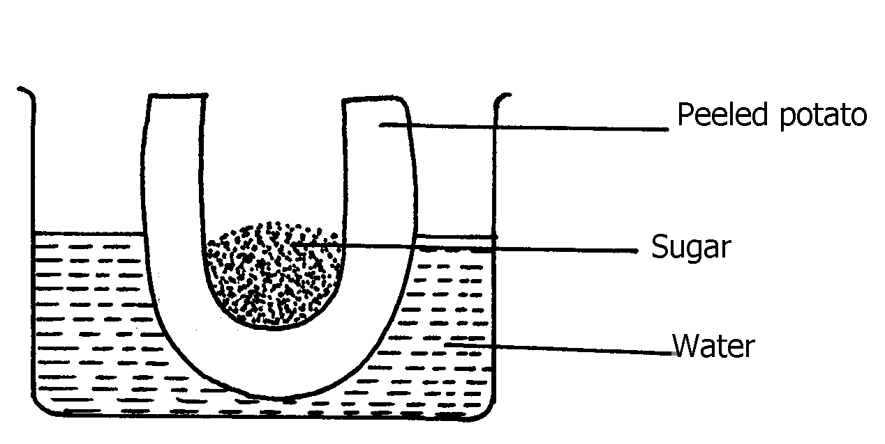

(a) State the expected result at the end of one hour (1 marks)
(b) Explain the observations made in this experiment (2 marks)

3. What are the two functions of bile salts during the process of digestion? (2 marks)

4. Name the diseases caused by deficiency of : (a) Iodine (1 mark)

(b) Vitamin C (1 mark)
5. Study the dental formula given below:
I 0; C 0 ; PM 3; M 2
4 0 3 3
(a) Identify with reasons the mode of feeding of the animals whose dental formula is
given above. (2 marks)

(b) Calculate the total number of teeth in the mouth of the above animal (1 mark)

6. A person whose blood group is AB requires a blood transfusion, name the blood groups of the donors. (2 marks)

7. (a) State three structural differences between arteries and veins in mammals (3 marks)

8. The equation below shows respiration for a certain food substrate. Study it and answer questions that follow:
2C₅₁H₉₈O₆ + 145O₂ 102CO₂ + 98H₂O
- Calculate the respiratory Quotient, RQ (2 marks)

- Suggest with reasons the possible food substrate (2 marks)

9. The figure below shows a vertical section through a mammalian kidney.

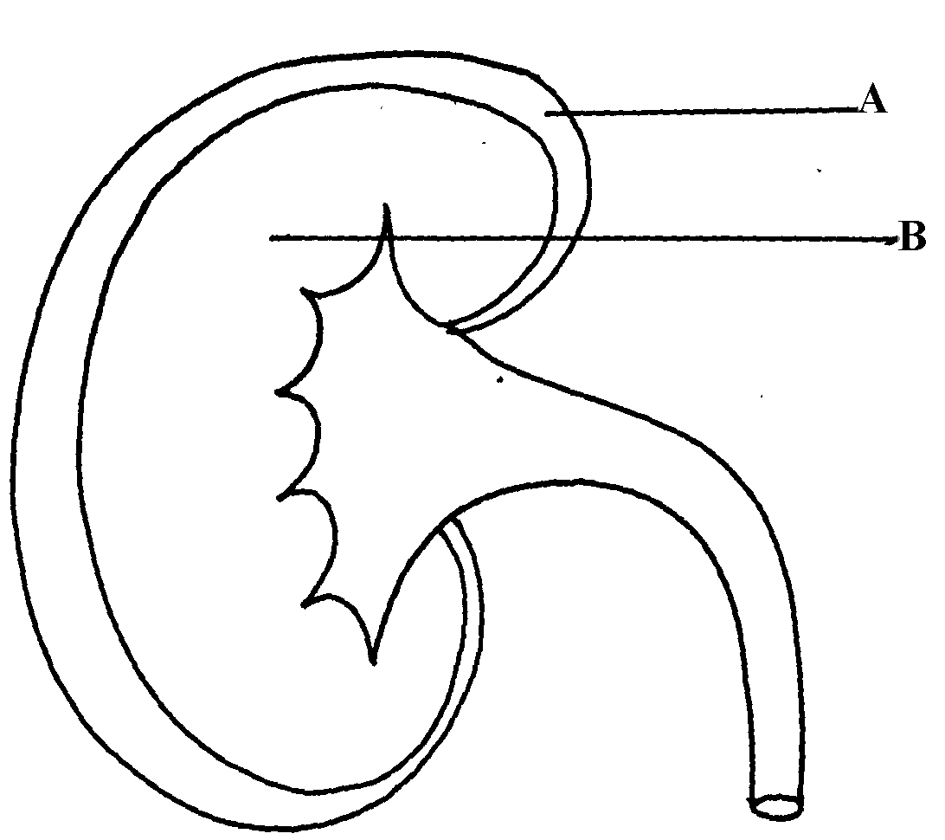

(a) Label the parts A and B (2 marks)

(b) Which part is the Bowman’s capsule found? (1 marks)

10. State the role of the following apparatus in the study of living things. (3 marks)
(a) Sweep nets. ____________________________________________________________
(b) Pooter. _______________________________________________________________
(c) Pit fall trap. ______________________________________________________________
11. Outline three roles of active transport in human body (3 marks)

12. Distinguish between community and population (2 marks)

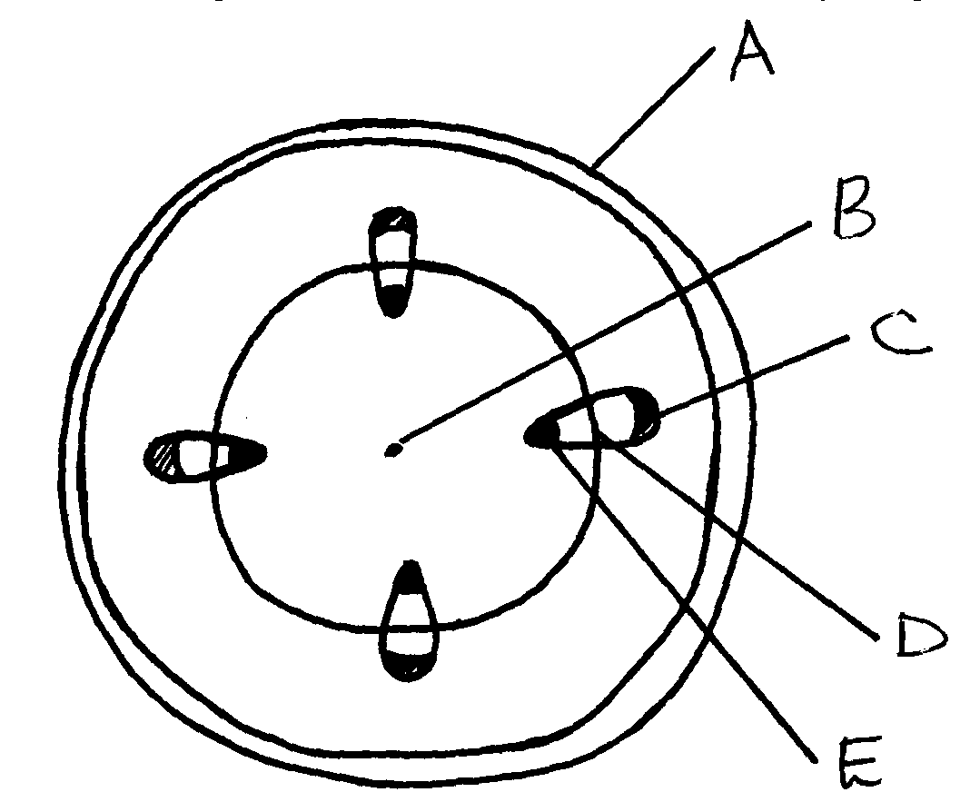
13. The diagram below represents a transverse section of a young stem.

(a) Name the parts labeled A, B and D (3 marks)

(b) State the functions of the parts labeled C and E (2 marks)

14. The diagram below represents a bread mould.
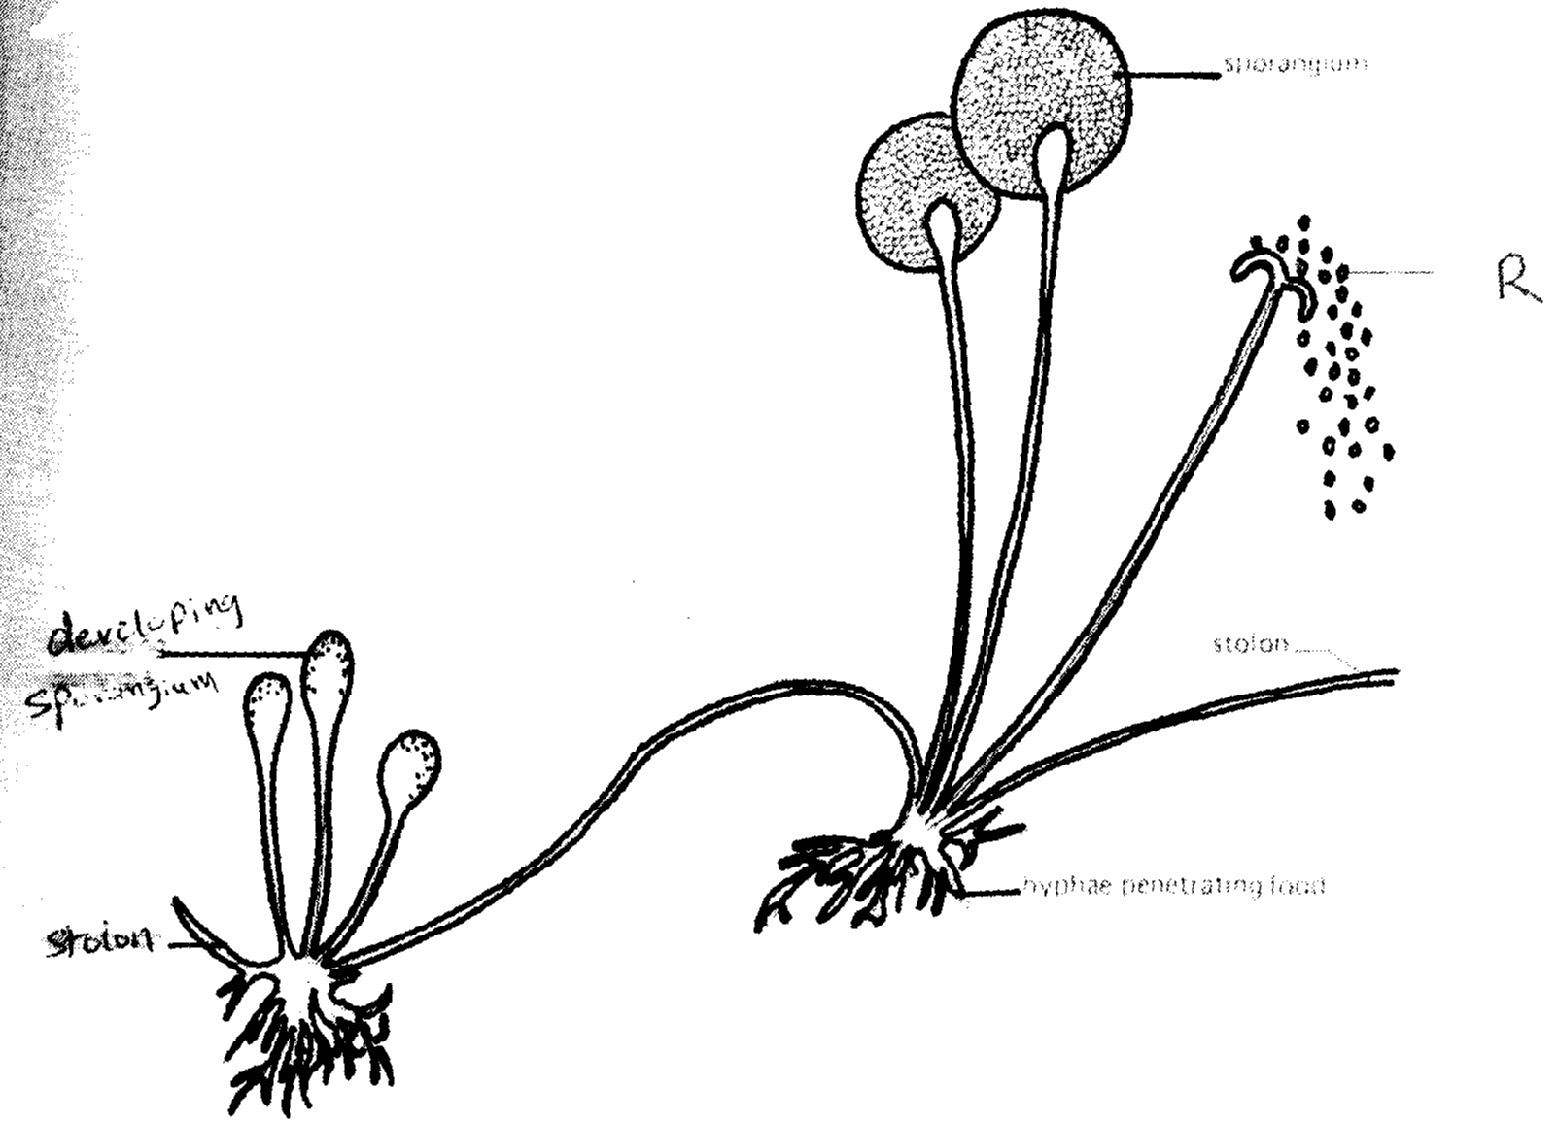
R
Stolon
Sporangum
Stolon
Hyphae penetrating food
Developing sporangium

(a) (i) Name the Kingdom to which bread mould belongs. 1 mark)

(ii) Give two distinguishing characteristics of the Kingdom named in (a)(i) above.(2 marks)

15. Explain four ways in which mammalian red blood cells are adapted to their function (4 marks)

SECTION B
16. An experiment was carried out to determine the effect of drinking on excess amount of water on the flow of urine. A person drinks one litre of water and urine was collected at intervals of 15minutes.
The results were as shown below:
Time in minutes | 0 | 15 | 30 | 45 | 60 | 75 | 90 | 105 | 120 | 135
Urine output ml/min | 1.6 | 1.6 | 1.6 | 5.4 | 9.0 | 9.0 | 7.6 | 3.0 | 0.8 | 0.8

(a) Plot a suitable graph to represent urine output with time. (7 marks)

(b) Explain the rate of flow of urine between the following times;
(i) 15 and 60minutes. (2 marks)

(ii) 60 and 75minutes. (2 marks)

(iii) 75 and 135 minutes. (2 marks)

(c) Name two hormones responsible for regulation of relative amount of salts and water in man. (2 marks)

(d) Name the parts of a nephron (5 marks)

ANSWER EITHER QUESTION 17 OR QUESTION 18

17. (a) What is meant by the term ‘digestion’? (2 marks)

(b) Describe how the mammalian small intestine is adapted to its function (18 marks)

18. Describe how a leaf is adapted to its function (20 marks)

………………………………………………………………………………………………………………………………………………………………………………………………………………………………………………………………………………………………………..………………………………………………………………………………………………………………………………………………………………………………………………………………………………………………………………………………………………………..
………………………………………………………………………………………………………………………………………………………………………………………………………………………………………………………………………………………………………..
………………………………………………………………………………………………………………………………………………………………………………………………………………………………………………………………………………………………………..
………………………………………………………………………………………………………………………………………………………………………………………………………………………………………………………………………………………………………..
………………………………………………………………………………………………………………………………………………………………………………………………………………………………………………………………………………………………………..
………………………………………………………………………………………………………………………………………………………………………………………………………………………………………………………………………………………………………..
………………………………………………………………………………………………………………………………………………………………………………………………………………………………………………………………………………………………………..
………………………………………………………………………………………………………………………………………………………………………………………………………………………………………………………………………………………………………..
………………………………………………………………………………………………………………………………………………………………………………………………………………………………………………………………………………………………………..
………………………………………………………………………………………………………………………………………………………………………………………………………………………………………………………………………………………………………..
………………………………………………………………………………………………………………………………………………………………………………………………………………………………………………………………………………………………………..
………………………………………………………………………………………………………………………………………………………………………………………………………………………………………………………………………………………………………..
………………………………………………………………………………………………………………………………………………………………………………………………………………………………………………………………………………………………………..
………………………………………………………………………………………………………………………………………………………………………………………………………………………………………………………………………………………………………..
………………………………………………………………………………………………………………………………………………………………………………………………………………………………………………………………………………………………………..
………………………………………………………………………………………………………………………………………………………………………………………………………………………………………………………………………………………………………..
………………………………………………………………………………………………………………………………………………………………………………………………………………………………………………………………………………………………………..
………………………………………………………………………………………………………………………………………………………………………………………………………………………………………………………………………………………………………..
………………………………………………………………………………………………………………………………………………………………………………………………………………………………………………………………………………………………………..
………………………………………………………………………………………………………………………………………………………………………………………………………………………………………………………………………………………………………..
………………………………………………………………………………………………………………………………………………………………………………………………………………………………………………………………………………………………………..
………………………………………………………………………………………………………………………………………………………………………………………………………………………………………………………………………………………………………..
………………………………………………………………………………………………………………………………………………………………………………………………………………………………………………………………………………………………………..
………………………………………………………………………………………………………………………………………………………………………………………………………………………………………………………………………………………………………..
………………………………………………………………………………………………………………………………………………………………………………………………………………………………………………………………………………………………………..
………………………………………………………………………………………………………………………………………………………………………………………………………………………………………………………………………………………………………..
………………………………………………………………………………………………………………………………………………………………………………………………………………………………………………………………………………………………………..
………………………………………………………………………………………………………………………………………………………………………………………………………………………………………………………………………………………………………..
………………………………………………………………………………………………………………………………………………………………………………………………………………………………………………………………………………………………………..
………………………………………………………………………………………………………………………………………………………………………………………………………………………………………………………………………………………………………..
………………………………………………………………………………………………………………………………………………………………………………………………………………………………………………………………………………………………………..
………………………………………………………………………………………………………………………………………………………………………………………………………………………………………………………………………………………………………..
………………………………………………………………………………………………………………………………………………………………………………………………………………………………………………………………………………………………………..

