BIOLOGY FORM TWO: END OF TERM ONE EXAM
NAME:……………………………………………………………………ADM NO:……………………CLASS………………
1 (a) what is meant by the term classification (1mk)
……………………………………………………………………………………………………………………………………………
(b) The scientific a house fly is MUSCA DOMESTICA (3mks)
- Write the name correctly:………………………………………………………………………
- Identify the genus and species names

Genus: ……………………………… Species: ……………………………………………….
2. Name the organelles that perform each of the following functions: (2mks)
a) Digestion and destruction of worn out organelles.
…………………………………………………………………………………………………………………………………..
b) Osmoregulation
………………………………………………………………………………………………………………………………………
3. State the functions of the following cell organelles: (2mks)
(a)Nucleolus; …………………………………………………………………………………………………………………………
(b)Plasma membrane;………………………………………………………………………………………………………
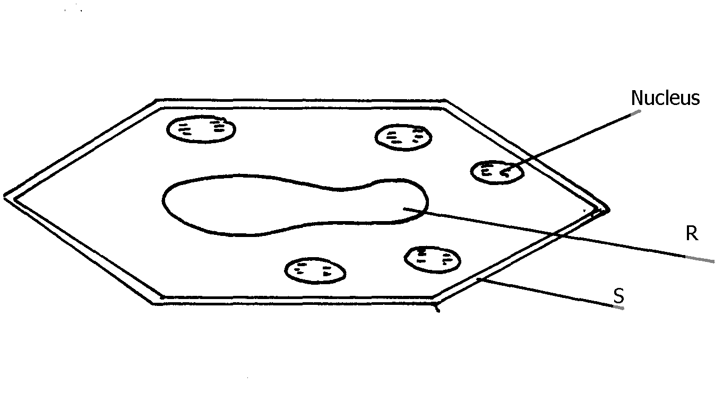
4. The diagram below represents a plant cell

- Name a carbohydrate that is stored in this type of cell. (1mk)
…………………………………………………………………………………………………………………………………………

- State two functions of the part labelled R (2mks)
…………………………………………………………………………………………………………………………………………………………………………………………………………………………………………………………………………………………………………………………………………………………………………………………………………………………………………………………………………………………………………………………………………………
(c) Name two structures present in the diagram but absent in the animal cell (2mks) ……………………………………………………………………………………………………………………………………………………………………………………………………………………………………………………………………………………
5. State the functions of each of the following parts in a microscope. (2mks)
(a)The eye piece lens …………………………………………………………………………………………………………

- The objective lens…………………………………………………………………………………………………………

6. An experiment was set-up as shown below and left for one hour
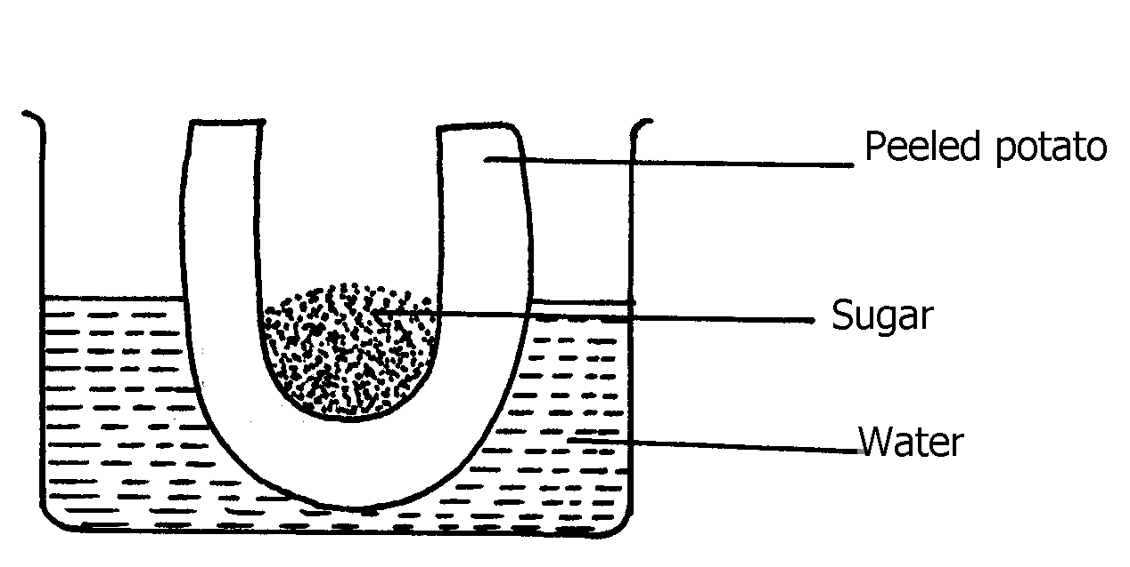

- State the expected result at the end of one hour (2mks)

(b) Explain the observations made in this experiment (2mks)
7. The diagram below shows the traverse section of a young stem.
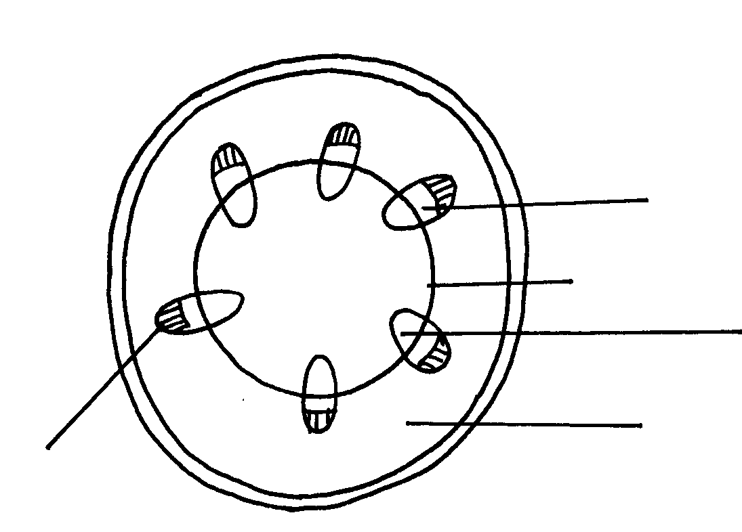
E
A
B
C
D

( a) Name the structures labeled A, B and C (3mks)
A: …………………………………………………………………………………………………………………………...
B: …………………………………………………………………………………………………………………………….
C: ……………………………………………………………………………………………………………………………..
(b)What type of cells are found in the part labeleld D (1mk)
……………………………………………………………………………………………………………………………

(c) Name the tissue labeled E (1mk)
……………………………………………………………………………………………………………………………….
8. Distinguish between guttation and transpiration (2mks)
………………………………………………………………………………………………………………………………………………………………………………………………………………………………………………………………………………………. …………………………………………………………………………………………………………………………………………………………………………………………………………………………………………………………………………………………
9. The diagram below shows part of a longitudinal section of a young root.

- Name the parts labeled A-D (4mks)
A………………………………………………………………… B………………………………………………………………….
C…………………………………………………………………
D………………………………………………………………….
(b) State the importance of root hairs (2mks)
………………………………………………………………………………………………………………………………………………………………………………………………………………………………………………………………………………………………
10. State the main of light in photosynthesis (2mks) ……………………………………………………………………………………………………………………………………………………………………………………………………………………………………………………………………………………
11. The diagram below represents a cell organelle
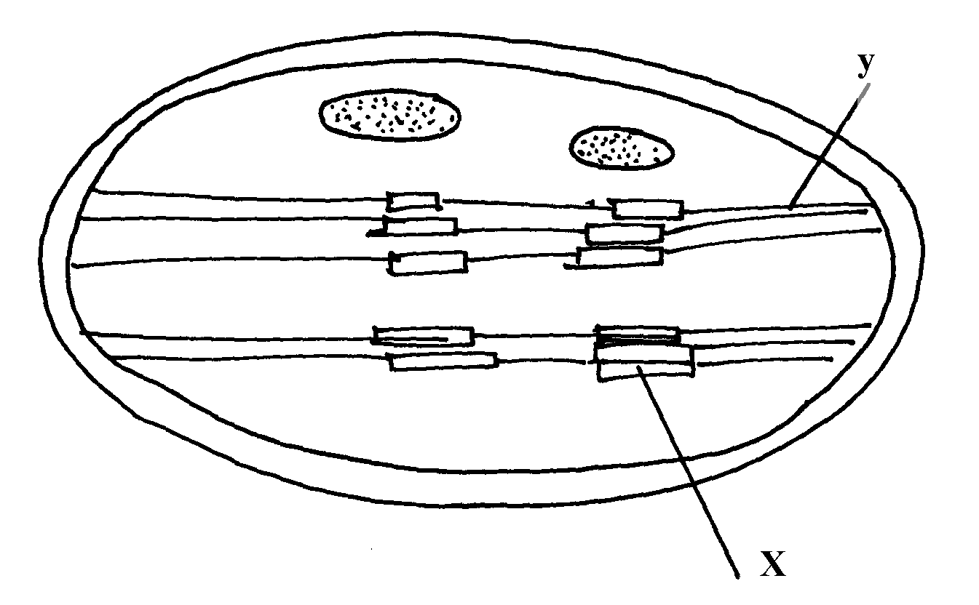

i) Suggest the identity of the cell organelle (1mk)
…………………………………………………………………………………………………………………………………………….
ii) Name the part labeled Y ………………………………………………………………………………………… (1mk)

ii) State the function of the part labeled X (1mk)
…………………………………………………………………………………………………………………………………………………….
12. Below is a diagram of a vertical section of a mammalian tooth

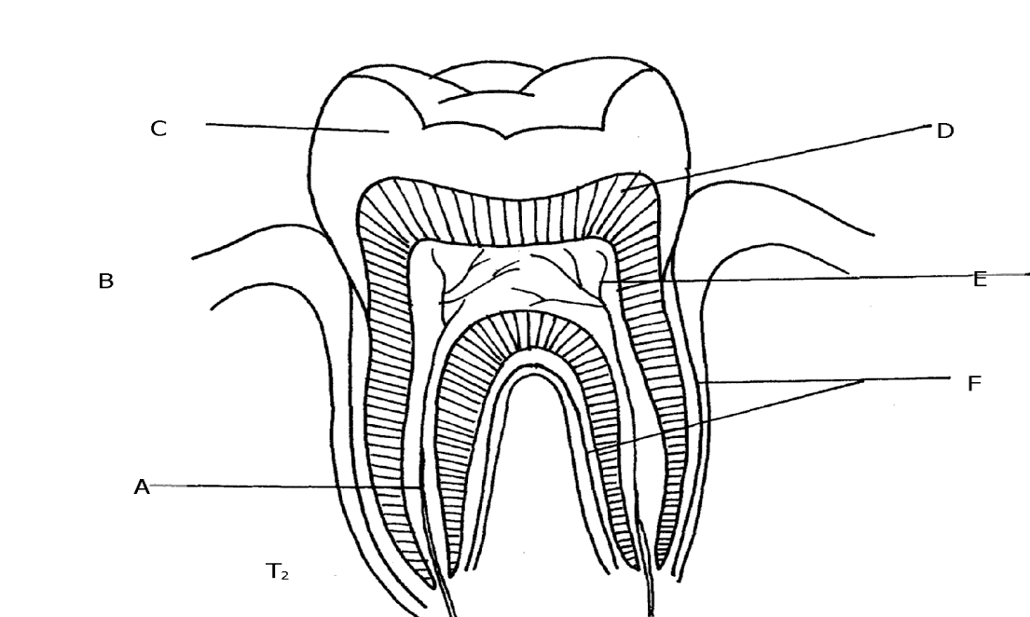

- Name the parts labeled C, D & E (3mks)
C
D
E
- State the function of the structures labeled C (1mk)
…………………………………………………………………………………………………………………………………………………………………………………………………………………………………………………………………………………..
- Suggest giving reasons what type of tooth this is (2mks)
Tooth:……………………………………………………………………………………………………………………………….
Reason:………………………………………………………………………………………………………………………………

- List any three ways of preventing teeth diseases (3mks)
…………………………………………………………………………………………………………………………………………………………………………………………………………………………………………………………………………………………………………………………………………………………………………………………………………………………………………………………………………………………………………………………………………………………………………
13. State three contents of gastric juice and in each case state their role (6mks)
Content | Function

14. Explain how the following factors affect the rate of photosynthesis (4mks)
(a)Temperature …………………………………………………………………………………………………………………………………………………………………………………………………………………………………………………………………………………………………………………………………………………………………………………………………………………………………
- Substrate concentration
………………………………………………………………………………………………………………………………………………………………………………………………………………………………………………………………………………………………………………………………………………………………………………………………………………………………
15. State the functions of the following chemicals of life (4mks)
a)Lipids……………………………………………………………………………………………………………………………………………………………………………………………………………………………………………………………………………………………
b)Vitamins
……………………………………………………………………………………………………………………………………………………………………………………………………………………………………………………………………………………………………….

SECTION B
ANSWER EITHER QUESTION 16 OR 17
16. a) What is meant by digestion? (2mks)
(b) Describe how mammalian small intestine is adapted to its functions (10 mks) (c) Explain how the following nutrients are assimilated (8mks)
- Glucose
- Amino acids
- Fatty acids
17. a) What is transpiration (2mks)
b) Explain the importance of transpiration to a plant (6mks)
c) Explain how the structural factors of a leaf may affect the rate of transpiration. (12mks)

