NAME………………………………………………………………………………………………….ADM NO…………………………………
FORM TWO CHEMISTRY
MID-TERM EXAM 100MKS
ANSWER ALL QUESTIONS.

- a). Study and complete the table below 3mks
Particle | Mass number | No. of protons | No. of Neutrons | No. of electrons
S²⁻ | 32 | 16 | - | -
Li⁺ | - | 3 | 4 | -
Cl⁻ | 37 | - | - | 18

b). Explain why alkaline earth metals are generally less reactive than alkali metals. 2mk

c) The order of reactivity increases down group 1 but decreases down group (vii). Explain 2mks

- The electron arrangement of ions X⁺² and Y⁻³ are 2.8.8 and 2.8 respectively. Write the
electron arrangement of the atoms of
X - (1mk)
- (1mk)

3. The valency of X is 3, What is the formulae of its

(i) Hydroxide. (1mk)

(ii) Sulphate. (1mk)
- Rubidium is a member of the alkali metal group. Predict products formed when it reacts with
- Chlorine gas

- Air

- Water. 3mks

- Why the reaction between calcium and dilute sulphuric acid will not go to completion. 2mks

- Group 8 elements are known as noble gases.
- Explain their lack of reactivity.

1mk
- Why are the nobel gas structure important in bonding between elements

2mks
.
- Explain the following trends observed in the periodic table.
i) Atomic radii increases down the group in alkali metals 2mks

ii) Melting point increases from sodium to aluminium in the third period. 2mks

iii) Chlorine is more reactive than sulphur. 2mks

- a) Why is the atomic radius of magnesium bigger than its ionic radius.

1mk

b) The valances of metals P, Q,& R are 1, 2 and 3 respectively. Write the formula of
- Hydroxide of Q

- Hydrogen carbonate of P

- Sulphate of R 3mks
- The table below gives some elements in the periodic table. Use it to answer the questions that follow. The letter do not represent the actual symbols.
Element | A | B | C | D | E
Atomic Number | 12 | 13 | 14 | 15 | 16
Which of the following letters represent
a). A non-metallic element with the largest atomic size? Explain 2mks

b). A metallic element which form ions with the smallest ionic radius? Explain 2mks

9. Given the two particles 19 and 20
X X
9 9
(i) Indicate the number of neutrons in 19 (1/2mks)
X
9
(ii) Indicate the number of electrons in 20 (1/2mks)
X
9

(iii) What phenomenon does X show? (1/2mks)

(iv) A mixture of the two types of X above contains 67% of 19 and 33% of 20. Calculate the relative atomic mass of x.
X X
9 9 (2mks)

- a) Both sodium and aluminium are metals in period 3, yet sodium has a much lower melting point than aluminium. Explain (1mk)

b) Explain why electrical conductivity of metals decrease with increase in temperature. (2mks)

c). Explain why aluminum conducts electric current better than sodium ( 1mk)

- Use the set-up below to answer the questions that follows.
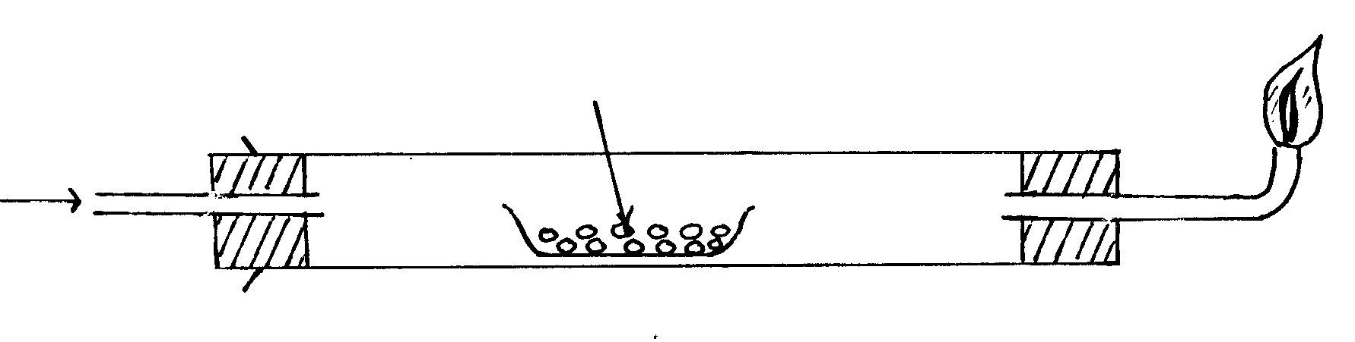
Dry hydrogen gas
Copper II oxide
a) Why is excess hydrogen burnt at the end of the tube. (1mk)

b) What type of reaction is occurring in the combustion tube? (1mk)
c) State one use of hydrogen gas. (1mk)

- a). Explain why the ionic radius in alkali metals is small than the atomic radius.
(1 mk)

b). State and explain the trend in atomic radius in halogens. (1 mk)

c). Define the terms below mean (2 mks)
i). ionization energy

ii). Octet state.

d). Explain why Melting points and boiling points increase down the group in halogens.
(1 mk)

e). State and explain the observation made when iodine is heated. (2 mks)

1.3. Against each mixture write down suitable methods of separation.
- Coloured extracts of grass dissolved in ethanol.

- Kerosine from Crude oil.

- Ammonium chloride from Sodium chloride.
(1/2.mks)

- Why is fractional distillation suitable for separating crude oil constituents? (1mk)

- ame
- Cleansing agents for removing these stains from your school dress: (3mks)
- Oily and greasy

- Blood stains

- Perspiration stains

- Monica a form one student decides to separate powdered calcium carbonate from powdered calcium chloride by shaking the mixture with water and then filtering. Would this procedure succeed? Explain your answer. (3mks)

- In an experiment, dry hydrogen chloride gas was passed through heated Zinc turnings as shown in the diagram below. The gas produced was then passed through heated Lead II Oxide.

Tube L Zinc turnings

Dry HCl _{(g)} PbO
TUBE V

HEAT gas

Flask z
_________________ water

- What is the function of the water in the flask? (1mk)

- Write equations for the reactions that took place in the tubes. (2mks)

iii) How would the total mass of tube V and its contents compare before and after the experiment? Explain (2mks)

- An experiment was set up as shown in the diagram below.

Delivery tube

_____ _________

water

@ @@@ Moist iron fillings
Explain what is observed after a few days. (3MKS)

- Give four differences between temporary and permanent changes.

Temporary changes | Permanent changes
(4mks)
- In extraction of oil a solvent is used. Name the solvent and its purpose in the extraction.
(2mks)

- Dilute sulphuric acid was add to a compound ‘P’ of magnesium. The solid reacted with the acid to form a colourless solution ,’Q’ and a colourless gas ‘R’ which formed a white precipitate when bubbled through lime water.
- Name :
- Compound p
ii. Solution Q
iii. Colourless gas R (3mks)
- Write the equation for the reaction that took place.
(2mks)
- What would be observed if calcium is used in place of magnesium?

(2mks)
- The following are some of the methods used to collect gases. With reasons state which method is suitable for each of the following gases, Ammonia, carbon (IV)oxide, chlorine, oxygen.

A B

C

- Ammonia –
Reason –
- Carbon dioxide –
Reason –
- Oxygen-
Reason-
(3mks)
- The grid below represents part of the periodic Table. Study it and answer the questions that follow. The letters are not the actual symbols of the elements.

O Q R S
T U
V Z

- Which element will require the least amount of energy to remove one of the outermost electrons? (1mk)

- Select the most reactive non-metal. (1mk)

- Which of the elements has the greatest tendency of forming covalent compound? Explain.
(2mks)

- What name is given to the family of elements to which elements O, T and V belong?

(1mk)

- An element W has atomic number 15. Indicate the position of W on the grid and give the period and groud of element W. (2mks)

- Explain why the atomic radius of S is smaller than that of R. (2mks)

- Chlorine is a member of halogens. It dissolves in water to form a mixture of two products. Write the reaction between water and chlorine. Explain what happens when the products are exposed to sunlight. (3mks)

- Give the reason why aluminium does not react with water. (2mks)

26) Explain the following observations.
a) Alkaline earth metals are generally less reactive than alkali metals. (1mk)

b) The order of reactivity increases down group 1 but decreases down group (vii). 2mks)

- A candle was burnt in air as shown below by a form one student. He made some observations as the burning progresses.

a) State the observations made at. 2mks
M

N

E N D

