TERM 2 MID TERM EXAM 2012
FORM FOUR BIOLOGY

NAME:…………………………………………………..........INDEX ………………..…..…….

- Name the branch of biology that deals with the study of zooplanktons. (1 mark)
………………………………………………………………………………………………
- The following diagram shows a feeding relationship in an ecosystem.
Small fish
Microscopic plants
Mosquito larvae
Large-fish
Crocodiles

a) From the diagram, write down a food chain with crocodile as the tertiary consumer. (1 mk)
………………………………………………………………………………………………

b) Which of the above organism would you expect to have the highest population?
(1mk)
………………………………………………………………………………………………
c) Give reason for your answer in (b) above (1mk)
………………………………………………………………………………………………………………………………………………………………………………………………
- a) Define accommodation of the eye. (1 mk)
………………………………………………………………………………………………………………………………………………………………………………………………
b) State two causes of hypermetropia in humans. (1mk)
………………………………………………………………………………………………
- a) Distinguish between homoiotherms and poikilotherms in homeostasis. (2 marks)
………………………………………………………………………………………………………………………………………………………………………………………………………………………………………………………………………………………………
b) Explain the significance of thermoregulation in living organism. (1mark)
................................................................................................................................................................................................................................................................................................
- The diagram below shows part of alimentary canal of a mammal.
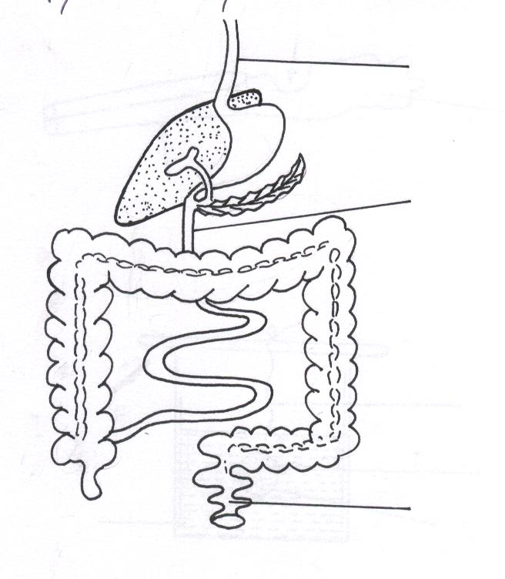
B
A
C
(i)Name the parts labeled.
A……………………………………………. (1 mark)
C……………………………………………. (1 mark)
(ii) State the function of the part labeled B. (1 mark)
……………………………………………………………………………………
- a) How are the male parts of wind pollinated flowers adapted to their functions? (2marks)
………………………………………………………………………………………………………………………………………………………………………………………........
- The experimental set-up shown below was placed outside for some days.
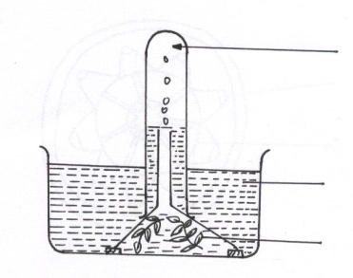
Elodea plant
Water containing sodium hydrogen carbonate
Gas
The rate of bubbles given off per unit time from the plant was measured. The results obtained are as shown below.

Days | weather | Average number of bubbles per minute
1 | Cloudy and dull | 4
2 | Quite sunny | 15
3 | Bright sunshine | 25
4 | Less cloudy | 8

a) Explain why the plant produces bubbles in the experiment above. (2marks)
………………………………………………………………………………………………………………………………………………………………………………………………
b) State the role of sodium carbonate in the set-up. (1 mark)
………………………………………………………………………………………………
c) What conclusion can be drawn from the results obtained in this experiment(1mk?)
………………………………………………………………………………………………
- The following key can be used to identify the five kingdom of classification.
- a) Has nuclear membrane …………………………………go to2
b) Nuclear membrane absent………………………. Kingdom A
- a) Body form made of hyphae……………………… Kingdom B
b) Body form without hyphae……………………… go to 3
- a) Some unicellular, others multi-Cellular……… Kingdom C
b) All multi-cellular…………………………………. Go to 4
- a) Feed autotrophically……………………………. Kingdom D.
b) Feed hetrotrophically….………………………… Kingdom E
a) Identify the kingdom.
(i) C…………………………………………………………............. (1 mark)
(ii) E…………………………………………………………. ........... (1 mark)
b) Apart from the characteristics mentioned in the key above, state two distinguishing features of Kingdom B. (2 marks)
……………………………………………………………………………………………………………………………………………………………………………………
- A blood transfusion was to be carried out to a patient who was badly injured in a road accident. His plasma contained antibody a.
a) Name two blood groups who would be donors. (2marks)

b) Explain your answer in (a) above. (1mark)
………………………………………………………………………………………………
- a) Temperature affects the rate of osmosis. Explain. (2 marks)
...............................................................................................................................................................................................................................................................................................
- An experiment was set-up as shown.
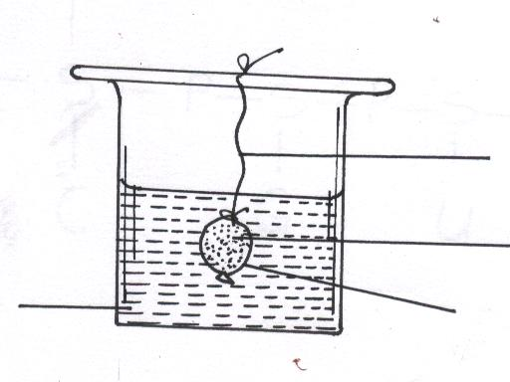
The set-up was left for 20 minutes.
i) State the expected results (1mark)
………………………………………………………………………………………………
ii) Explain your answer in (a) above. (3marks)
………………………………………………………………………………………………………………………………………………………………………………………………
- Give the function of each of the following parts of the ear. (2mks)
- (i) Ear ossicles...............................................................................................................
…………………………………………………………… ………..............................
(ii)Tympanic membrane……………………………………………………................... .................................................................................................................................... b) Blowfly maggots (larvae) quickly burrow into decaying flesh as soon as they are exposed to light. Name this type of response. (1mark)
………………………………………………………………………………………………
- a) Name the hormone responsible for ovulation in human females. (1marks)
………………………………………………………………………………………………
b) Give two roles of the placenta. (2marks)

- The figure below is a structural diagram of a portion from nucleic acid strand
–– –– –– S –– P –– S –– P –– S –– P –– S

C G U C
a) Giving a reason, name the nucleic acid to which the portion belongs. (2mks)
Name…………………………………………………………………………..
Reason…………………………………………………………………………
b) Write down the sequence of bases of a complimentary strand to that shown above.

(1 mark)
- The chart below is a summary of a blood clotting process.
Prothrombin X
Y Thrombokinase
Thrombin

Fibrinogen Z

a) Name the blood cell represented by X …………………………………………. (1 mark)
b) Name the metal ion represented Y…………………………………………… (1mk)
c) What is the biological importance of the blood clotting process (2mks)
16.The diagram below represents a reflex arc.

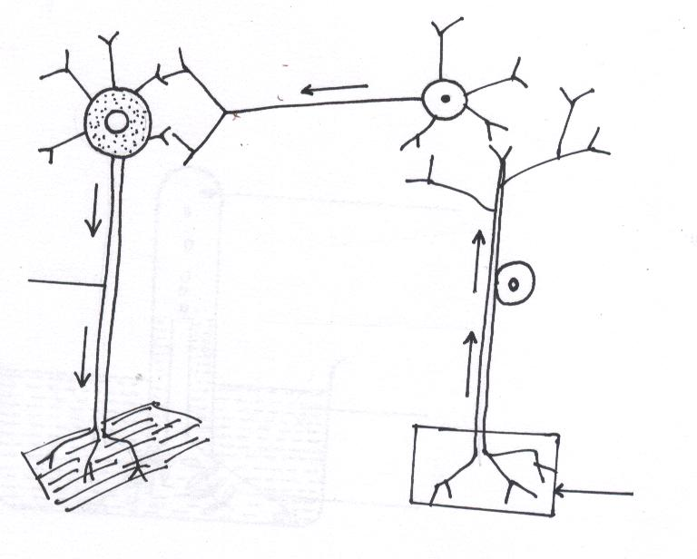
a) Name the parts labeled X and Y. (2mks)

b) State two adaptations of X to its functions. (2mks)
………………………………………………………………………………………………………………………………………………………………………………………………
17. State three adaptations of fruits and seeds to animal dispersal. (3mks)
(i)……………………………………………………………………………………………

(ii) …………………………………………………………………………………………..

(iii) …………………………………………………………………………………………

18. Suggest an explanation for the increased number of red blood cells found in the blood of people normally living at high altitude. (2mks)
19. Other than root pressure, state two other forces involved in transportation of water and mineral salts. (2mks)
………………………………………………………………………………………………………
20. State three ways in which seed dormancy benefits a plant (3mks)
........................................................................................................................................................................................................................................................................................................................
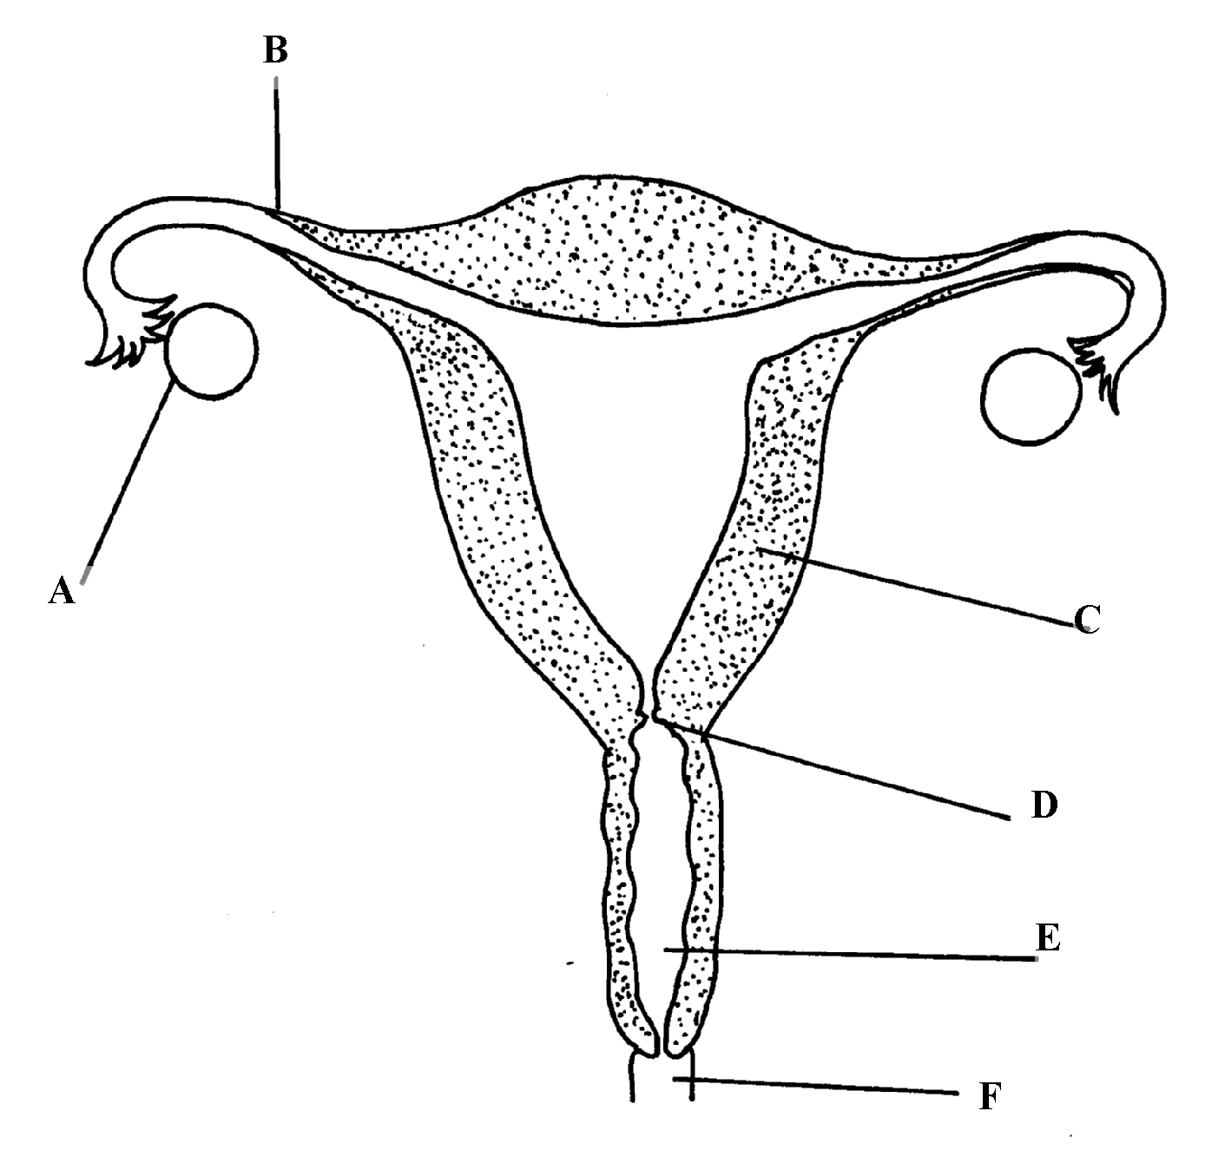
21. The diagram below represents female reproductive system;

a) Name the part labeled; A, B, and D (3mks)
A ……………………………………………………………………………………………
B……………………………………………………………………………………………..
D ……………………………………………………………………………………………
b) State two functions of structure A (2mks)
.........................................................................................................................................................................................................................................................................................................................
c) How is part C adapted to its function? (1mk)
………………………………………………………………………………………………………………………………………………………………………………………………………………
SECTION B
22. Explain how the mammalian eye is adapted to its function (20mks)
........................................................................................................................................................................................................................................................................................................................ ........................................................................................................................................................................................................................................................................................................................ ........................................................................................................................................................................................................................................................................................................................ ........................................................................................................................................................................................................................................................................................................................ ........................................................................................................................................................................................................................................................................................................................ ........................................................................................................................................................................................................................................................................................................................ ........................................................................................................................................................................................................................................................................................................................ ........................................................................................................................................................................................................................................................................................................................ ........................................................................................................................................................................................................................................................................................................................ ........................................................................................................................................................................................................................................................................................................................ ........................................................................................................................................................................................................................................................................................................................ ........................................................................................................................................................................................................................................................................................................................ ........................................................................................................................................................................................................................................................................................................................ ........................................................................................................................................................................................................................................................................................................................ ........................................................................................................................................................................................................................................................................................................................ ........................................................................................................................................................................................................................................................................................................................ ........................................................................................................................................................................................................................................................................................................................ ........................................................................................................................................................................................................................................................................................................................ ........................................................................................................................................................................................................................................................................................................................ ........................................................................................................................................................................................................................................................................................................................ ........................................................................................................................................................................................................................................................................................................................ ........................................................................................................................................................................................................................................................................................................................ ........................................................................................................................................................................................................................................................................................................................ ........................................................................................................................................................................................................................................................................................................................ ........................................................................................................................................................................................................................................................................................................................ ........................................................................................................................................................................................................................................................................................................................ ........................................................................................................................................................................................................................................................................................................................ ........................................................................................................................................................................................................................................................................................................................ ........................................................................................................................................................................................................................................................................................................................

