BIOLOGY FORM THREE

Name……………………………………..…………………ADM No………………CLASS……………

1. Mango is known as MANGIFERA INDICA
i) Write down the scientific name given above following the acceptable system of naming. …………………………………………………………………………………………… ( 1mk)
ii) What is the scientific naming system called. (1mk)
……………………………………………………………………………………………………….
2. On the table below state three differences between mitosis and meiosis. (3mks)

Mitosis | Meiosis

3. Name two substances formed in the mammalian liver. (2mks)
……………………………………………………………………………………………………….
……………………………………………………………………………………………………….
4. Give the importance of leaf mosaic in the process of photosynthesis. (1mk)
……………………………………………………………………………………………………….
5. Study the diagram below and answer the questions that follow:
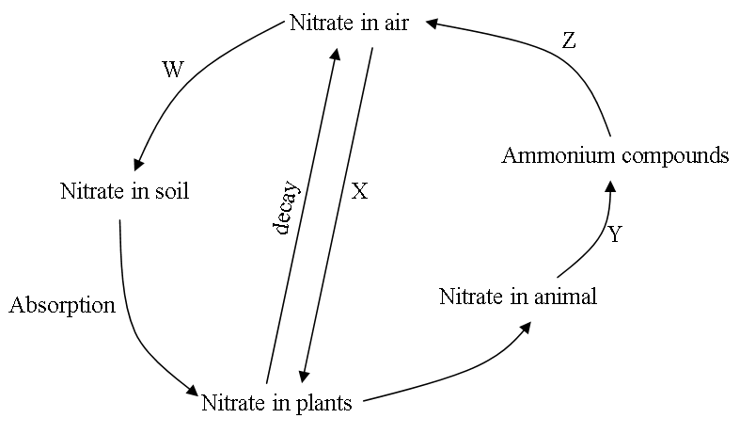
a) Name the micro-organism W. (1mk)

b) i) Name the micro-organism X. (1mk)
……………………………………………………………………………………………………….
……………………………………………………………………………………………………….
ii) Name the biological process Y and Z. (2mks)
Y ………………………………...........................................................
Z ...........................................................................................................
6. a) Explain the importance of gradual release of heat energy in a cell during respiration. (1mk)
……………………………………………………………………………………………………….
……………………………………………………………………………………………………….
b) Name the products of glycolysis. (2mks)
……………………………………………………………………………………………………….
……………………………………………………………………………………………………...
7. a) A man’s urine gave positive reaction with Benedict’s solution. Name the disease he
was suffering from. (1mk)
……………………………………………………………………………………………………….
……………………………………………………………………………………………………….
b) State two ways in which the symptoms of the condition in (a) above can be controlled. (2mks)
……………………………………………………………………………………………………….
……………………………………………………………………………………………………….
9. a) Name two structures present in plant cells but absent in animal cells. (2mks)
……………………………………………………………………………………………………….
……………………………………………………………………………………………………….
b) What is meant by
i) Crenation (1mk)
……………………………………………………………………………………………………….
ii) Haemolysis (1mk)
……………………………………………………………………………………………………….
10. Name the organelles that are in abundance in:- (3mks)
a) White blood cells...................................................................................................................
b) Skeletal muscles. .................................................................................................................
c) Involved in osmoregulation in amoeba................................................................................
11. During the schools sports day, a student participated in a hundred meters race.
a) State three factors of the internal environment that changed. (2mks)
……………………………………………………………………………………………………….
……………………………………………………………………………………………………….
……………………………………………………………………………………………………….
b) Name the substance that accumulated in the muscles. (1mk)
……………………………………………………………………………………………………….
12. What is main difference between enzyme and other catalysts. (1mk)
…………………………………………………………………………………………………
13. The diagram below shows pollen tube entering the ovule of a flowering plant
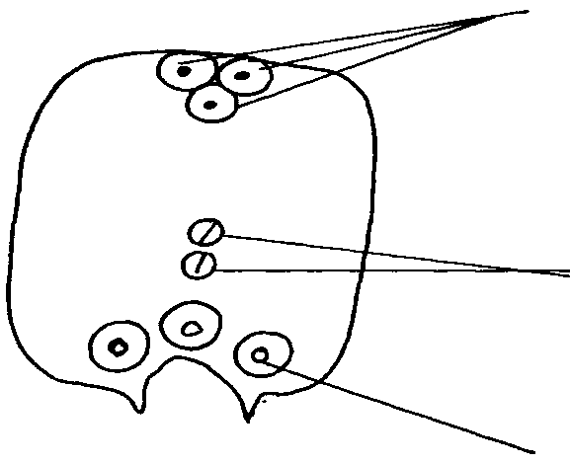
A

B

C
- Name the parts labeled A, B and D (3mks)
A
B
D
b) Name the kind of fertilization exhibited by the above flowering plant. (1mk)
.........................................................................................................................................................
14. State the functions of the following parts of the flower (2mks)
Corolla.........................................................................................................................................
................................................................................................................................................ Anther ........................................................................................................................................... .......................................................................................................................................................

15. State two ways in which nephrons of desert animals differ from those of man. (2mks)
……………………………………………………………………………………………………….
……………………………………………………………………………………………………….
16 Outline any two adaptations of the mammalian skin that provide protection (2mks)
……………………………………………………………………………………………………….
……………………………………………………………………………………………………….

17. Study the diagram below.

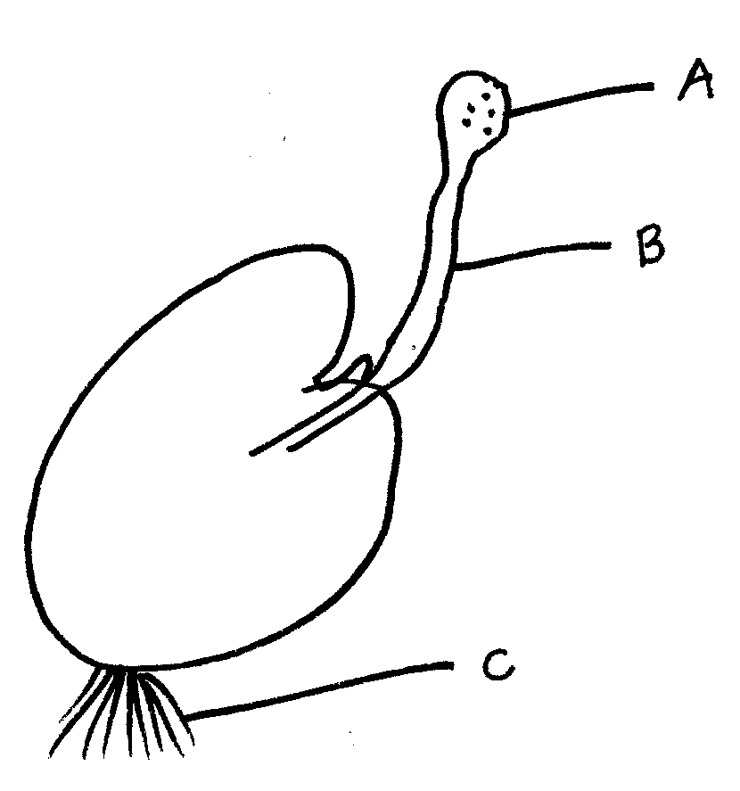
a) State the division in which the organism belongs. (1mk)
……………………………………………………………………………………………………….
b) Name the parts labelled A and B. (2mks)
……………………………………………………………………………………………………….
……………………………………………………………………………………………………….
c) What is the function of part labelled C. (1mk)
……………………………………………………………………………………………............
18. The figure below shows a section through a leaf. A leaf is designed for photosynthesis and this process provides a supply of simple sugars for a plant.
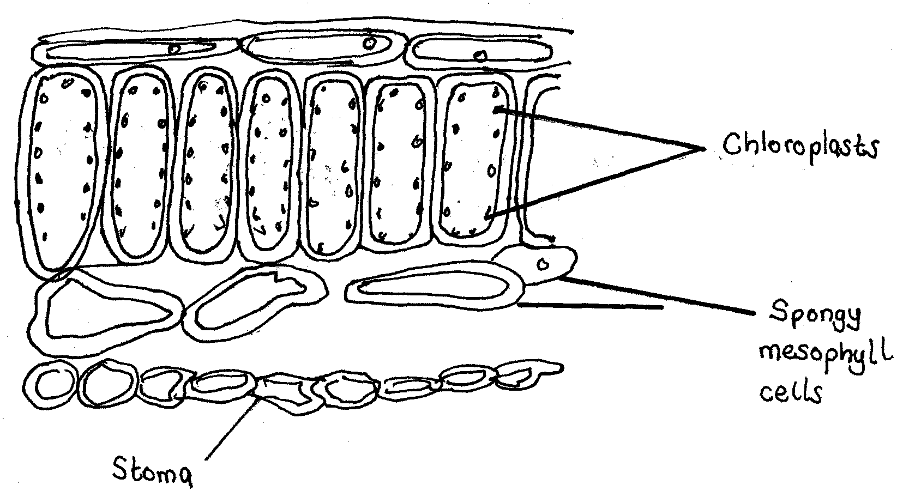
- State the adaption of the chloroplasts to photosynthesis. (2mks)
………………………………………………………………………………………………………
………………………………………………………………………………………………………
- Suggest the function of the stomata and the spaces between the spongy mesophyll cells in the process of photosynthesis. (2mks)
………………………………………………………………………………………………………
………………………………………………………………………………………………………
19. a) State the three features of the ileum that increase their surface area. (3mks)
………………………………………………………………………………………………………
………………………………………………………………………………………………………
………………………………………………………………………………………………………
b) Explain why digestion of starch which begins in the mouth does not continue in the stomach
………………………………………………………………………………………………………
…………………………………………………………………………………………… ........ ............................................................................................................................................ .(2mks)
c) State two functions of muscles found in the wall of alimentary canal. (2mks)
………………………………………………………………………………………………………
.............................................................................................................................................................
20. The diagram below shows a phenomenon which occurs during cell division.
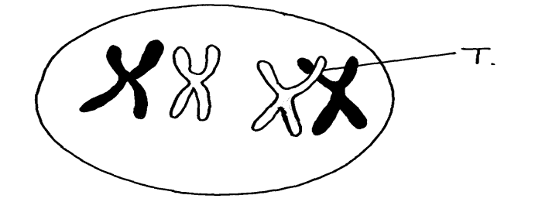

(a) Name the part labeled T. (1mk)
............................................................................................................................................................. (b) (i) State the biological importance of the part labelled T. (2mks)
.........................................................................................................................................................................................................................................................................................................................................................................................................................................................................................

(ii) Identify the type of cell division in which this phenomenon occurs. (1mk)
...............................................................................................................................................................
21. State two adaptations of the red blood cells to their function (2mks)

22. An experiment was carried out to investigate the population increase of yeast cells in a culture over a period of 48 minutes. The results were recorded as shown in the table below.
Time in min | Number of yeast cells
0 | 2
5 | 2
10 | 4
15 | 16
20 | 46
25 | 94
30 | 123
35 | 136
40 | 140
45 | 140
50 | 140
- Using a suitable scale plot a graph of number of yeast cells against time in minutes.(6mks)
b) i) Determine the number of yeast cells after 26 minutes . (1mk)

ii) Determine the number of yeast cells after 36 minutes. (1mk)
………………………………………………………………………………………………………
c) What was the rate of increase of yeast cells between 24 and 28 minutes (1mk)

………………………………………………………………………………………………………
d) After how long was the population of yeast cells 128? (1mk)

………………………………………………………………………………………………………
e) Account for the shape of the curve between:
i) O and 12 min. (2mks)
………………………………………………………………………………………………………
………………………………………………………………………………………………………
ii) 17 and 30 min . (3mks)
………………………………………………………………………………………………………
………………………………………………………………………………………………………
iii) 30 and 40 min. (2mks)
………………………………………………………………………………………………………
………………………………………………………………………………………………………
f) State the problems associated with rapid human population growth in Kenya today.( 3mks)

……………………………………………………………………………………………………… ………………………………………………………………………………………………………
………………………………………………………………………………………………………
………………………………………………………………………………………………………

