NAME...............................................ADM NO...........CLASS......

FORM THREE MATHEMATICS
END OF TERM 2 EXAMS

ANSWER ALL THE QUESTIONS IN THIS SECTION
- Evaluate without using a calculator expressing the answer as a fraction in simplest form
$\frac{5}{6}−\frac{1}{3}\text{of}\frac{\text{27}}{\text{20}}÷2$ (3 marks)

- Solve for x given that
16 ^{X2} = 8 ^{4X-3} (3 marks)

- Simplify the expression 4x² – 9y²
2x² + 3xy +5y² (3 marks)

- A bus travelling at an average speed of 60km/hr left a station at 6a.m.Acar later left the same station at 8.30a.m. and caught up with the bus at 9.45am.Find the average speed of the car (3 marks )

- Given that 2 ≤A ≤ 4 , 8 ≤ B ≤ 10, and that 6 ≤ C≤ 9 find the percentage error in AB
C - A
(3mks)

6) A Kenyan bank buys and sells foreign currencies at the exchange rates shown below
Buying Selling
Kshs Kshs
1 Euro 147.56 148.00
1 US Dollar 74.22 74.50
An American arrived in Kenya with 20,000 Euros. He converted all the euros to Kenya shillings at the bank. He spent Ksh 2510200 while in Kenya and converted the remaining Kenya shillings into US dollars at the bank. Find the amount in Dollars that he received. (4mks)

7) Line XY shown below is side of a triangle XYZ .Angle YXZ=30⁰ and XZ=9cm.

X Y

A) Using a ruler and a pair of compasses only complete the triangle XYZ (2mks)
b) Measure YZ ( 1mk)

8) Calculate the volume, in m³ of a golden ring of mass 57.9g if its density is 19.3 g/cm³ (2mks)

9) A solid cube whose length is 6.053cm is melted and the molten material used to make a solid metal sphere. Find to 1dp the radius of the metal sphere. (3mks)

0) The figure below shows a circle centre o radius 4 √ 2 cm and .AB =8cm.calculate the shaded area.
A B
OOOO

(3MKS)

11) Find the equation of the perpendicular to line AB through (0,3) given the coordinates of A and B are (-3, -2) and (6, 4) respectively. (3mks)

12) Use logarithms tables to evaluate
$\sqrt[3]{\frac{\text{36}\text{.}\text{72}×{\left(0\text{.}\text{46}\right)}^{2}}{\text{185}\text{.}4}}$ (3mks)

13) Given that θ is an acute angle and $\text{sin} θ = \frac{2\sqrt{3}}{5}$, find without using calculators or mathematical table, $\text{tan} {\left(\text{90}−x\right)}^{0}$. (3mks)

14) Given that log y = 3.143 and log x = 2.421, evaluate:$4 \text{log} y^{1/{}2 + \text{log} \sqrt[3]{x}}$ (3mks)

15) Given that $\frac{2\sqrt{2}}{1+\sqrt{3}}−\frac{\sqrt{3}}{1−\sqrt{3}}=a+b\sqrt{c}$. Find the values of a, b and c. (3mks)

16) using in equalities define the un-shaded region (4mks)

8

-4 6

17) (a) Three villages A, B and C are such that B is 3km on a bearing of 030⁰ from A, C is 4km on a bearing of 120⁰ from B.
  - Using a scale of 1cm to represent 0.5km, draw a diagram to show the relative positions of the village A, B and C. (3mks)
  - Find the distance and bearing of village A from C. (4mks)
b) A straight main road runs from village A to C. Find the length of the shortest path from village B to the main road. (3mks)

18) a) Given that A= (2,3) B=(12,13) Fine vector BA (2mks)

b) find /AB/ (2MKS)

c) Given that M is the midpoint of AB find the co-ordinates of M (2MKS)

d) Show that the three points are parallel (3MKS)

19)Triangle PQR has the vertices P (1,2), Q(7,2),and R(5,4)
a) Draw triangle PQR on the grid provided. (1mk)
b) P¹Q¹R¹ is the image of PQR under a reflection in the line X= -1. Draw triangle P¹Q¹R¹ and state its coordinates. (3mks)
c) P¹¹Q¹¹R¹¹ has the vertices P¹¹ (-3,-3), Q¹¹ (-3,2) , R¹¹ (-1,0). Draw triangle P¹¹Q¹¹R¹¹ on the same grid and describe the transformation that maps P¹Q¹R¹onto P¹¹Q¹¹R¹¹ (3mks)
D) Describe a single transformation that will map triangle PQR onto triangle P¹¹Q¹¹R¹¹ (3mks)

20 ) Mr. Omwega is employed. His basic salary is Kshs. 21, 750 and is entitled to a house allowance of Kshs 15, 000 and a travelling allowance of Kshs 8, 000 per month. He also claims a family monthly relief of Kshs 1, 056 per month. Other deductions are;
Union dues Kshs 200 and
Co-operative shares Kshs 4, 500 per month.
The table below shows the tax rates for the year.
Income (Kshs per annum) | Tax rates
1 – 116, 600  116, 161 – 225, 600  225, 601 – 335, 040  335, 041 – 444, 480  Over 444, 480 | 10%  15%  20%  25%  30%
Calculate;
- Mr. Omwega’s annual taxable income. (2 marks)

(b) The tax paid by Mr. Omwega in the year. (6 marks)

(c) Mr. Omwega’s net income per month. (2 marks)

21) The figure below shows a frustum of a cone with base radius = 3.3cm and top radius = 2.2cm.The height of the frustum is 4.8cm
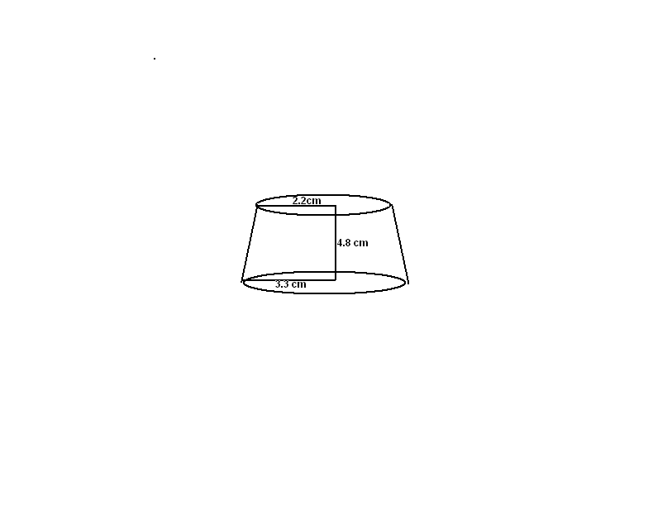

- Find the height of the original cone (2mks)

b) Calculate the area of the hemispherical surface of frustum (3mks)

- Calculate the slant height of the frustum (2mks)

- Calculate the volume of the frustum (3mks)

22) The table below shows marks scored by a hundred students in a physics test.

Marks | 30-34 | 35-39 | 40-44 | 45-49 | 50-54 | 55-59 | 60-64 | 65-69
Number of students | 4 | 6 | 10 | 14 | x | 24 | 14 | 6

(a) Determine the value of x (2mk)

b) Make cumulative frequency table (1mks)

(b) calculate:
(i) The mean mark (3mks)

(ii) State the modal class (1mks)

(iii) The median mark (3mks)

23) In the figure below O is the centre and PS is a diameter of the circle. QR is parallel to PS. If angle PSQ is 25⁰ and angle POT is 120⁰, find the sizes of the given angles giving reasons.
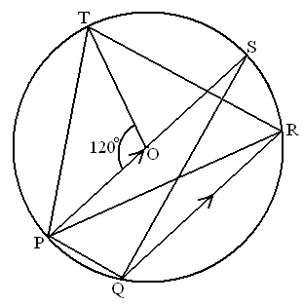
- Angle QRT (3mks

- Angle QPT (2mks)

- Angle PQR (3mks)

- Angle PTR (2mks)

24 ) Two intersecting circles have centers P and Q as shown below. The circle centre P has radius 8cm and that of centre Q has radius 9cm.
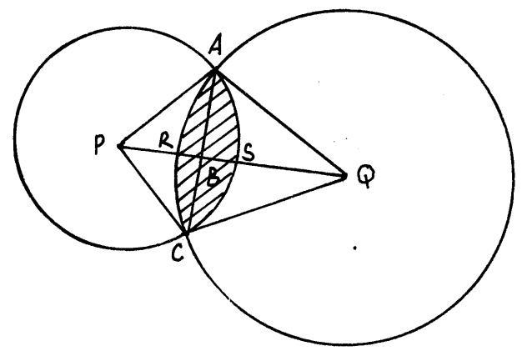

The distance between the centers PQ = 14cm and PB: BQ = 3:4.
Calculate:
(i) Angle APC (2mks)

(ii) Angle AQC (2mks)

(iii) The area of the shaded region (6mks)

