NAME.....................................................................ADM NO...............CLASS........
TERM 3 MID-TERM EXAM 2011
BIOLOGY FORM 3

1. Classification I &II

1. (a) In which kingdom do bacteria belong? (1mk)
..........................................................................................................................................................................
(b) Give any two benefits of bacteria to man ( 2mk
.................................................................................................................................................................................................................................................................................................................................................... ....................................................................................................................................................................................................................................................................................................................................................
2. Name the phylum whose members possess notochord ( 1mk)
..........................................................................................................................................................................
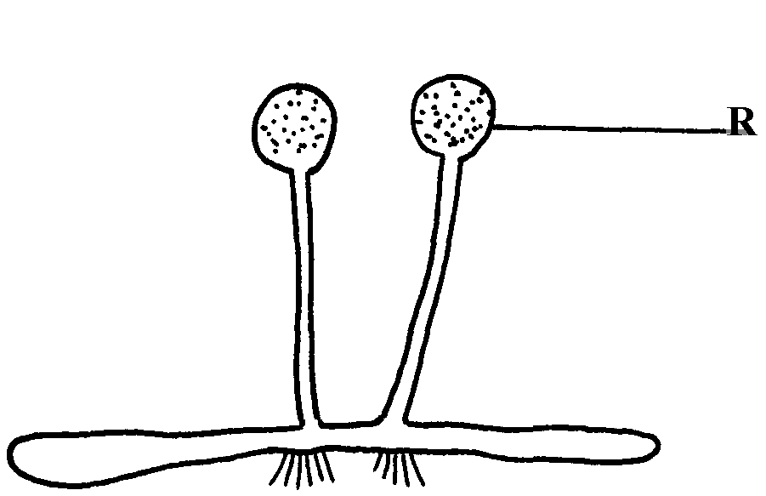
3. The diagram below represents a bread mould:-

(a) Identify the kingdom to which the organism belongs:- (1mk)
..........................................................................................................................................................................
(b) State the function of structure R (1mk)
....................................................................................................................................................................................................................................................................................................................................................
4. A student caught an animal which had the following characteristics:-
    - Body divided into two parts
    - Simple eyes
    - Eight legs
Name the class to which the animal belongs (1mk)

..........................................................................................................................................................................
5. (a) What is meant by the term taxonomy? (1mk)
....................................................................................................................................................................................................................................................................................................................................................
(b) The scientific name of a rat is Rattus norvegicus. What distinguishes scientific names from ordinary names.
....................................................................................................................................................................................................................................................................................................................................................
Respiration
1. (a) Distinguish between gaseous exchange and respiration (1MK)
.................................................................................................................................................................................................................................................................................................................................................... ....................................................................................................................................................................................................................................................................................................................................................
(b) Name the products of anaerobic respiration in plants ( 1 MK)
..........................................................................................................................................................................
2. (a) State two phases of aerobic respiration (2 MK)
....................................................................................................................................................................................................................................................................................................................................................
(b) With a reason, state the phase that yields more energy (1MK)
....................................................................................................................................................................................................................................................................................................................................................
3. Give a reason why it is difficult to calculate respiratory quotient (RQ) in plants (1MK)
....................................................................................................................................................................................................................................................................................................................................................
4. One molecule of lipid gives more energy than one molecule of glucose when respired aerobically but it is NOT always used as a respiratory substrate. Give two reasons for this (2MK)

....................................................................................................................................................................................................................................................................................................................................................
....................................................................................................................................................................................................................................................................................................................................................
5. Whooping cough is a disease of the respiratory system name the causative agents and give two symptoms ( 2MK)
...................................................................................................................................................................................................................................................................................................................................................
Excretion and homeostasis
1. (a) State ONE structural modification of the kidneys of deserts animals like kangaroo rat. (1MK)
....................................................................................................................................................................................................................................................................................................................................................
(b) Describe how ingestion of very salty food may reduce the amount of water excreted in urine. (2MK)
....................................................................................................................................................................................................................................................................................................................................................
2. A student mixed a sample of urine from a person with Benedict’s solution and heated, the colour changed to orange.
(a) What was present in the urine sample? ( 1MK)
....................................................................................................................................................................................................................................................................................................................................................
(b) What did the student conclude on the health status of the person? ( 1MK)
..........................................................................................................................................................................
(c) Which organ in the person may not be functioning properly? (1MK)
....................................................................................................................................................................................................................................................................................................................................................
4. (a) What is poikilotherm? ( 1MK)
....................................................................................................................................................................................................................................................................................................................................................
(b) State ONE class of phylum chordata where all members are poikilothermic. (1MK)
..........................................................................................................................................................................
5. The equation below represents a metabolic process that occurs in a certain organ in the mammalian body:-
Ammonia enzymes Organic compound Q + water Carbon (IV) oxide
a) Name the process represented in the equation. ( 1MK)
..........................................................................................................................................................................
b) Name the organ in which the process occurs. (1MK)
..........................................................................................................................................................................
Classification I &II
1. (a) In which kingdom do bacteria belong? (1mk)
...................................................................................................................................................................................................................................................................................................................................................(b) Give any two benefits of bacteria to man ( 2mk)
........................................................................................................................................................................................................................................................................................................................................................................................................................................................................................................................................................................................................................................................................................................
2. Name the phylum whose members possess notochord ( 1mk)
3. The diagram below represents a bread mould:-

(a) Identify the kingdom to which the organism belongs:- (1mk)
.......................................................................................................................................................................... (b) State the function of structure R (1mk)
....................................................................................................................................................................................................................................................................................................................................................
4. A student caught an animal which had the following characteristics:-
    - Body divided into two parts
    - Simple eyes
    - Eight legs
Name the class to which the animal belongs (1mk)
..........................................................................................................................................................................
5. (a) What is meant by the term taxonomy? (1mk)
....................................................................................................................................................................................................................................................................................................................................................
(b) The scientific name of a rat is Rattus norvegicus. What distinguishes scientific names from ordinary names?
....................................................................................................................................................................................................................................................................................................................................................
9. Ecology
1. What is the significance of the following in the ecosystem? ( 2mk)
a) Decomposers
b) Predators
....................................................................................................................................................................................................................................................................................................................................................
3. Birds feed on grasshoppers that feed on grass. Draw a possible food chain from the above information (1mk)

4. Define the following terms:- (2mk)
(i) Autecology ;
....................................................................................................................................................................................................................................................................................................................................................(ii) Biomass;
....................................................................................................................................................................................................................................................................................................................................................
5. Give a reason why two species in an ecosystem cannot occupy the same niche (1mk)
....................................................................................................................................................................................................................................................................................................................................................
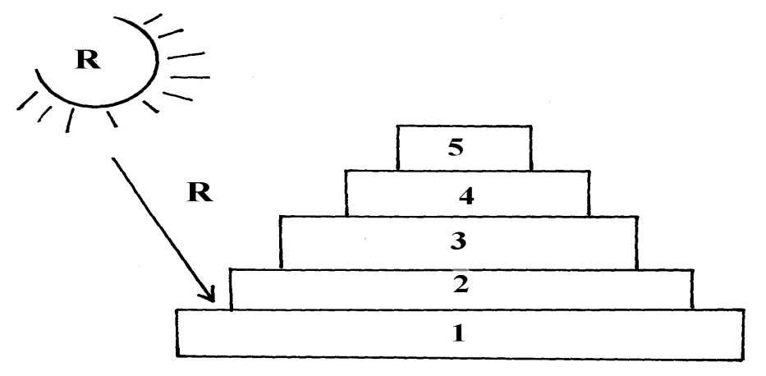
6. Below is a pyramid of numbers indicating trophic levels:-

(a) What do you understand by the term trophic level? (1mk)
....................................................................................................................................................................................................................................................................................................................................................
(b) Name the trophic level numbered 5 on the pyramid (1mk)
....................................................................................................................................................................................................................................................................................................................................................
(c) Name Q (1mk)
.......................................................................................................................................................................... (d)What is the significance of the arrow R ( 1mk)
....................................................................................................................................................................................................................................................................................................................................................

Reproduction
1. a) Name the part of an ovule that develops into testa in a seed after Fertilization (1MK) ....................................................................................................................................................................................................................................................................................................................................................
b) What is parthenocarpy? (1mk)
....................................................................................................................................................................................................................................................................................................................................................
2. State two roles of placenta during pregnancy. (2mk)
........................................................................................................................................................................................................................................................................................................................................................................................................................................................................................................................................................................................................................................................................................................
3. Name one way through which HIV/AIDS is transmitted (1mk
....................................................................................................................................................................................................................................................................................................................................................
7. The diagram below shows a phenomenon which occurs during cell division. ( 3mk)
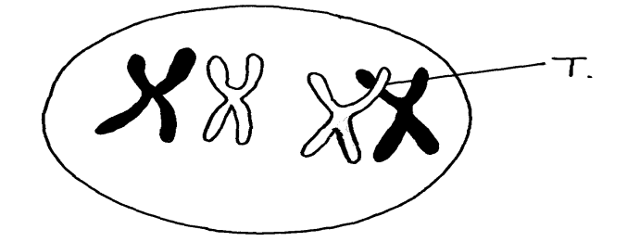

(a) Name the part labeled T. ___________________________________________________
(b) (i) State the biological importance of the part labelled T.
...............................................................................................................................................................................................................................................................................................................................................
(ii) Identify the type of cell division in which this phenomenon occurs.
...................................................................................................................................................................................................................................................................................................................................................
11. Name two mechanisms that hinder self fertilization in flowering plants
.................................................................................................................................................................................................................................................................................................................................................... ....................................................................................................................................................................................................................................................................................................................................................

